**Week 1 - Chapter 1- Introduction to TCP/IP – I**  **[ Network Overview ]**

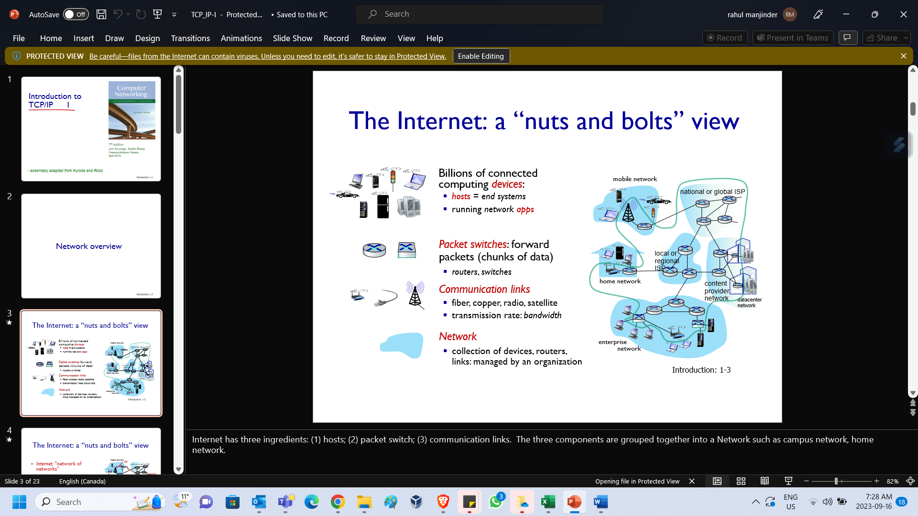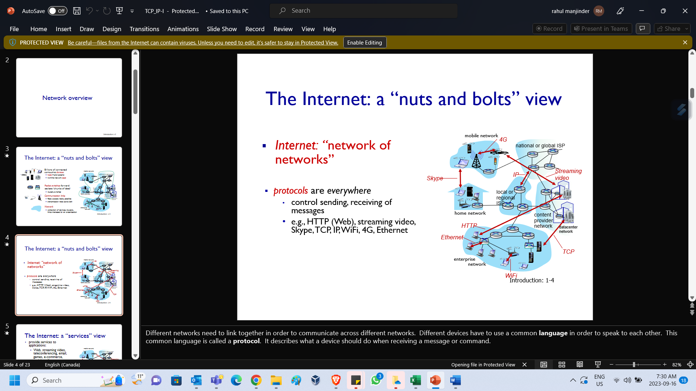

|  |  |
| --- | --- |
| Internet has three ingredients: (1) hosts; (2) packet switch; (3) communication links. The three components are grouped together into a Network such as campus network, home network. | Different networks need to link together in order to communicate across different networks. Different devices have to use a common **language** in order to speak to each other. This common language is called a **protocol**. It describes what a device should do when receiving a message or command. |

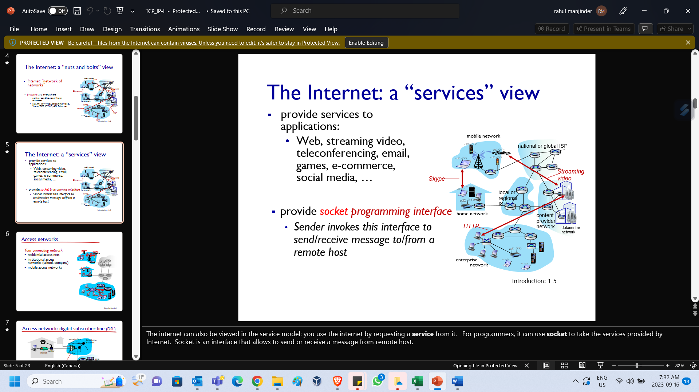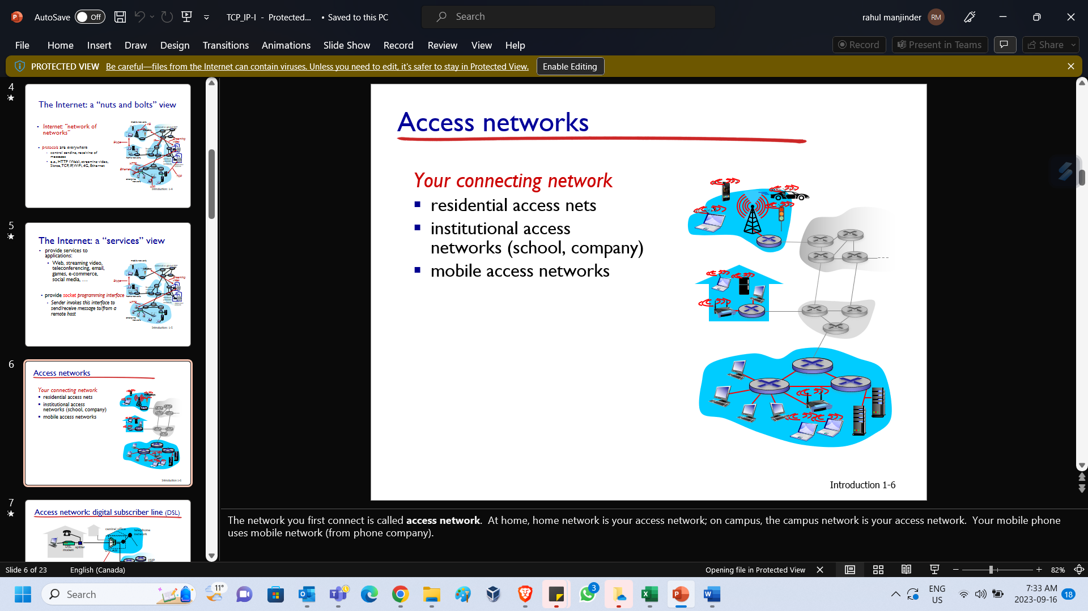

|  |  |
| --- | --- |
| The internet can also be viewed in the service model: you use the internet by requesting a **service** from it. For programmers, it can use **socket** to take the services provided by Internet. Socket is an interface that allows to send or receive a message from remote host. | The network you first connect is called **access network**. At home, home network is your access network; on campus, the campus network is your access network. Your mobile phone uses mobile network (from phone company). |

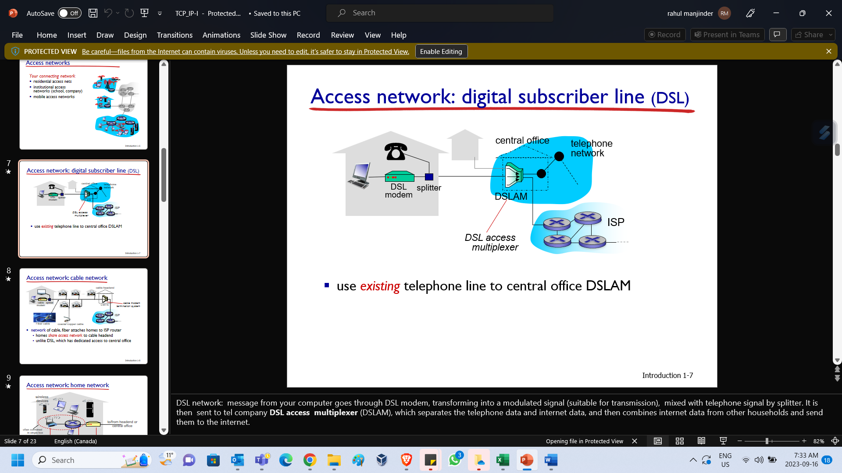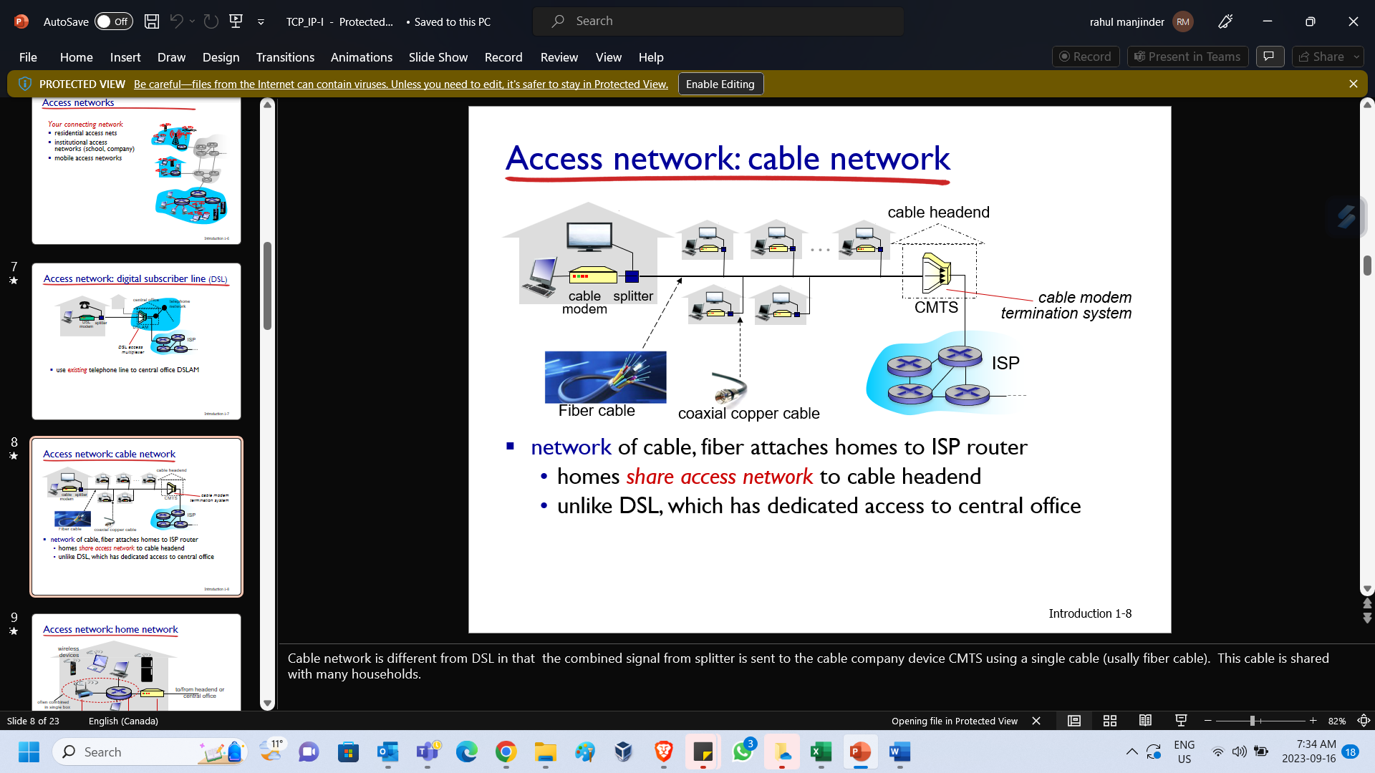

|  |  |
| --- | --- |
| DSL network: message from your computer goes through DSL modem, transforming into a modulated signal (suitable for transmission), mixed with telephone signal by splitter. It is then sent to tel company **DSL access multiplexer** (DSLAM), which separates the telephone data and internet data, and then combines internet data from other households and send them to the internet. | Cable network is different from DSL in that the combined signal from splitter is sent to the cable company device CMTS using a single cable (usually fiber cable). This cable is shared with many households. |

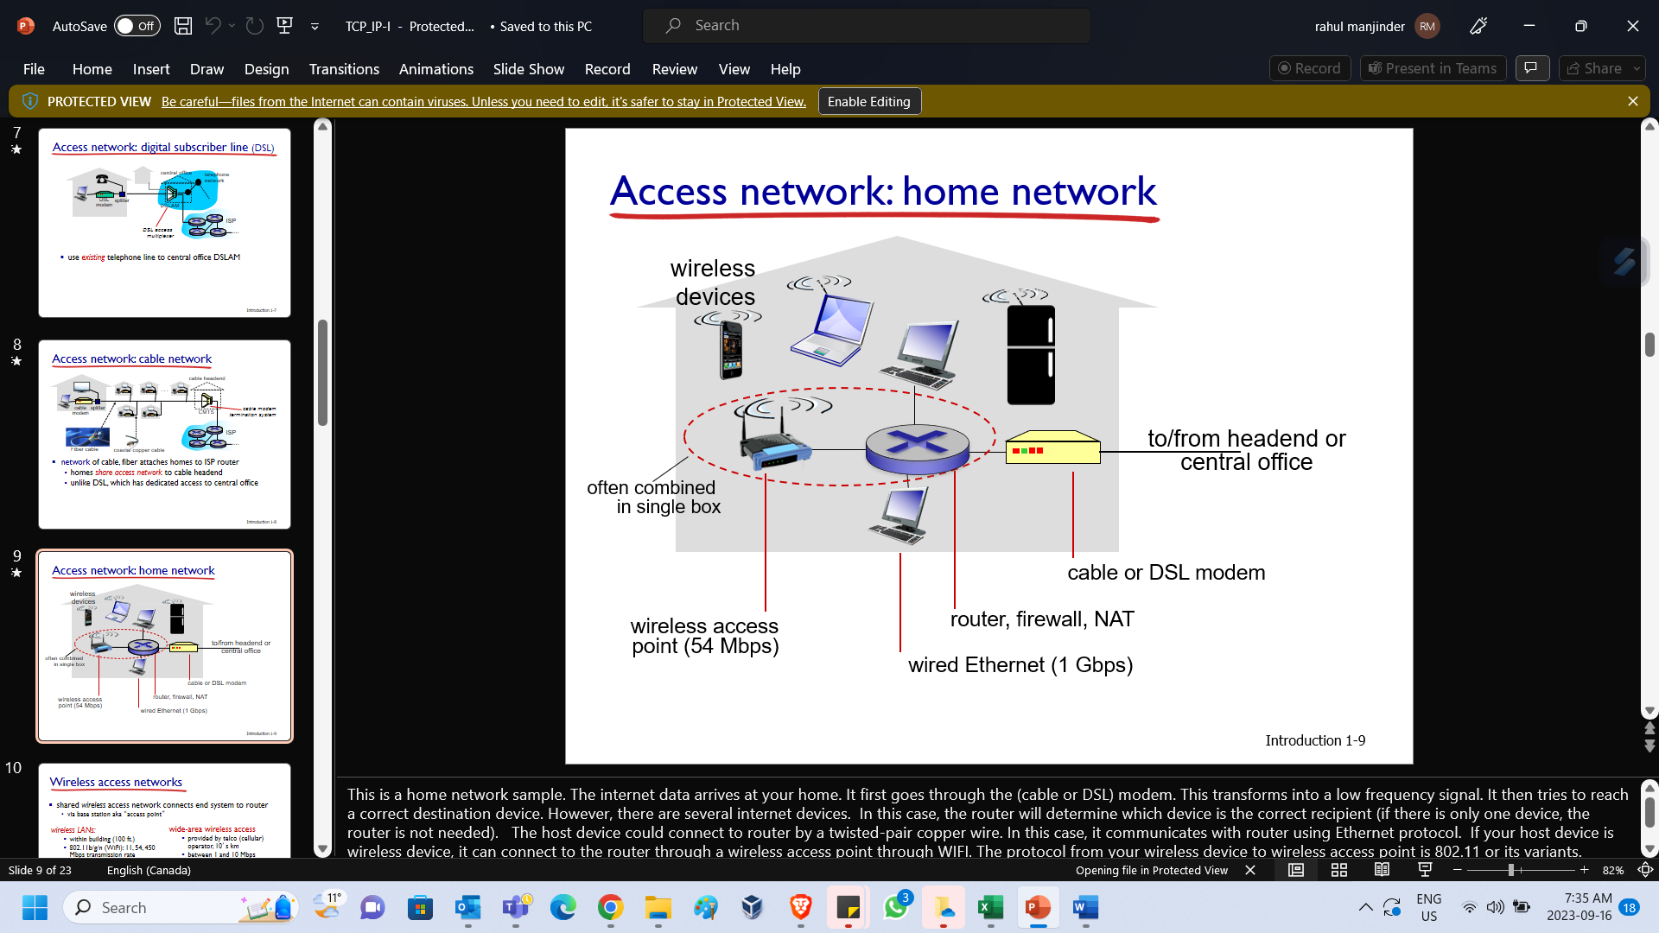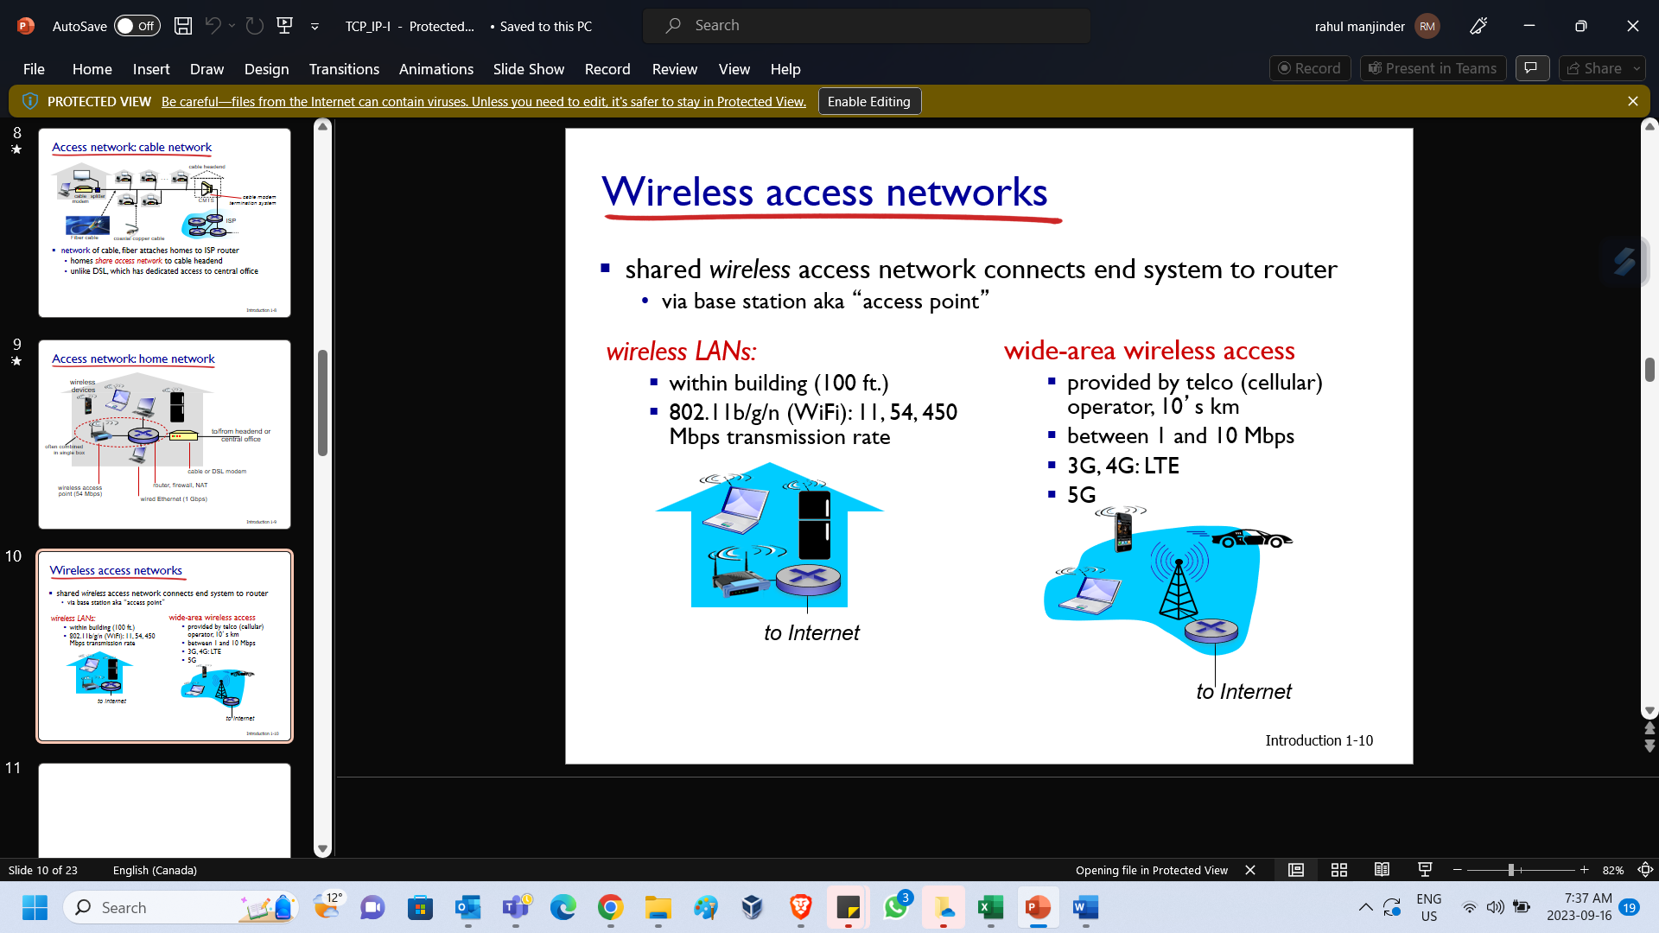

|  |
| --- |
| This is a home network sample. The internet data arrives at your home. It first goes through the (cable or DSL) modem.  This transforms into a low frequency signal. It then tries to reach a correct destination device.  However, there are several internet devices. In this case, the router will determine which device is the correct recipient (if there is only one device, the router is not needed).  The host device could connect to router by a twisted-pair copper wire. In this case, it communicates with router using Ethernet protocol. If your host device is wireless device, it can connect to the router through a wireless access point through WIFI. The protocol from your wireless device to wireless access point is 802.11 or its variants. Sometimes wireless access point, router or even modem are integrated into one device. |

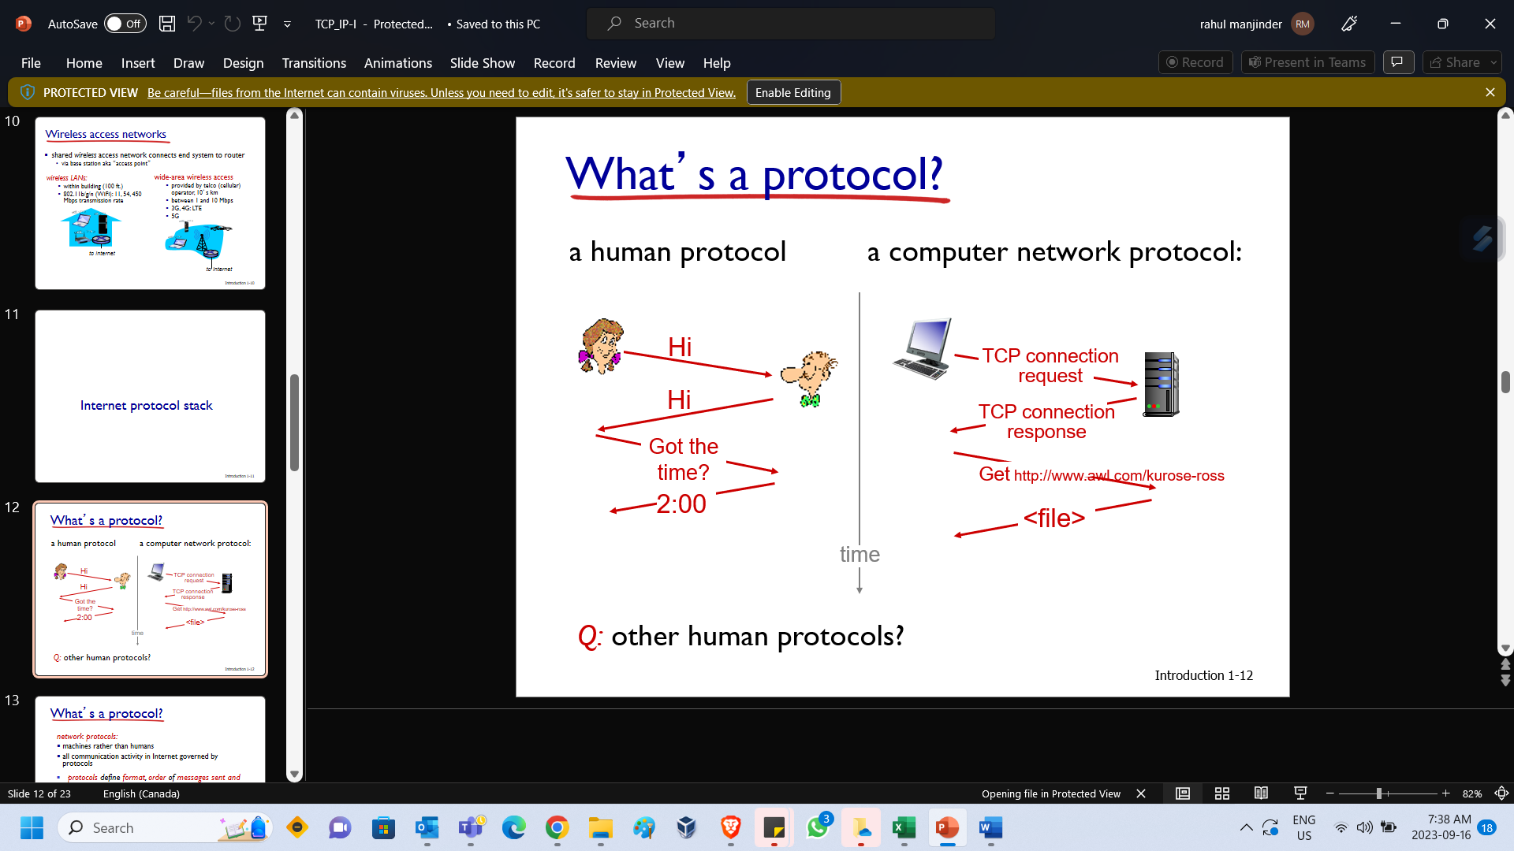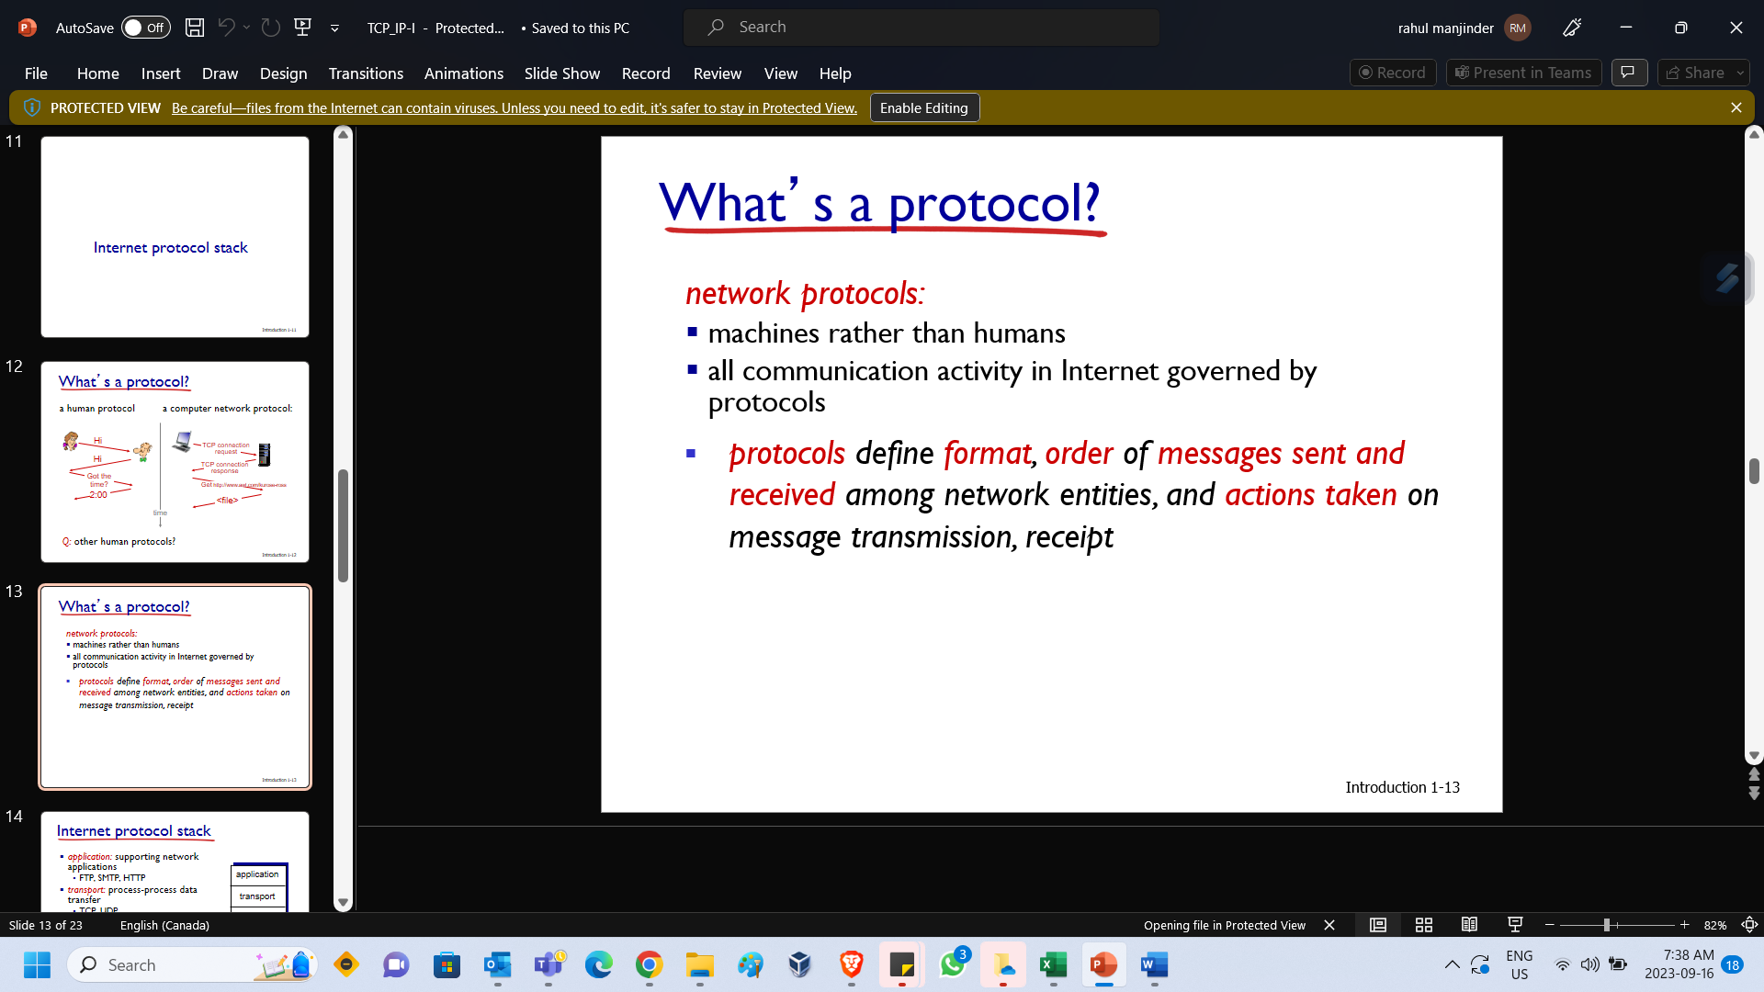

**INTERNET PROTOCOL STACK**

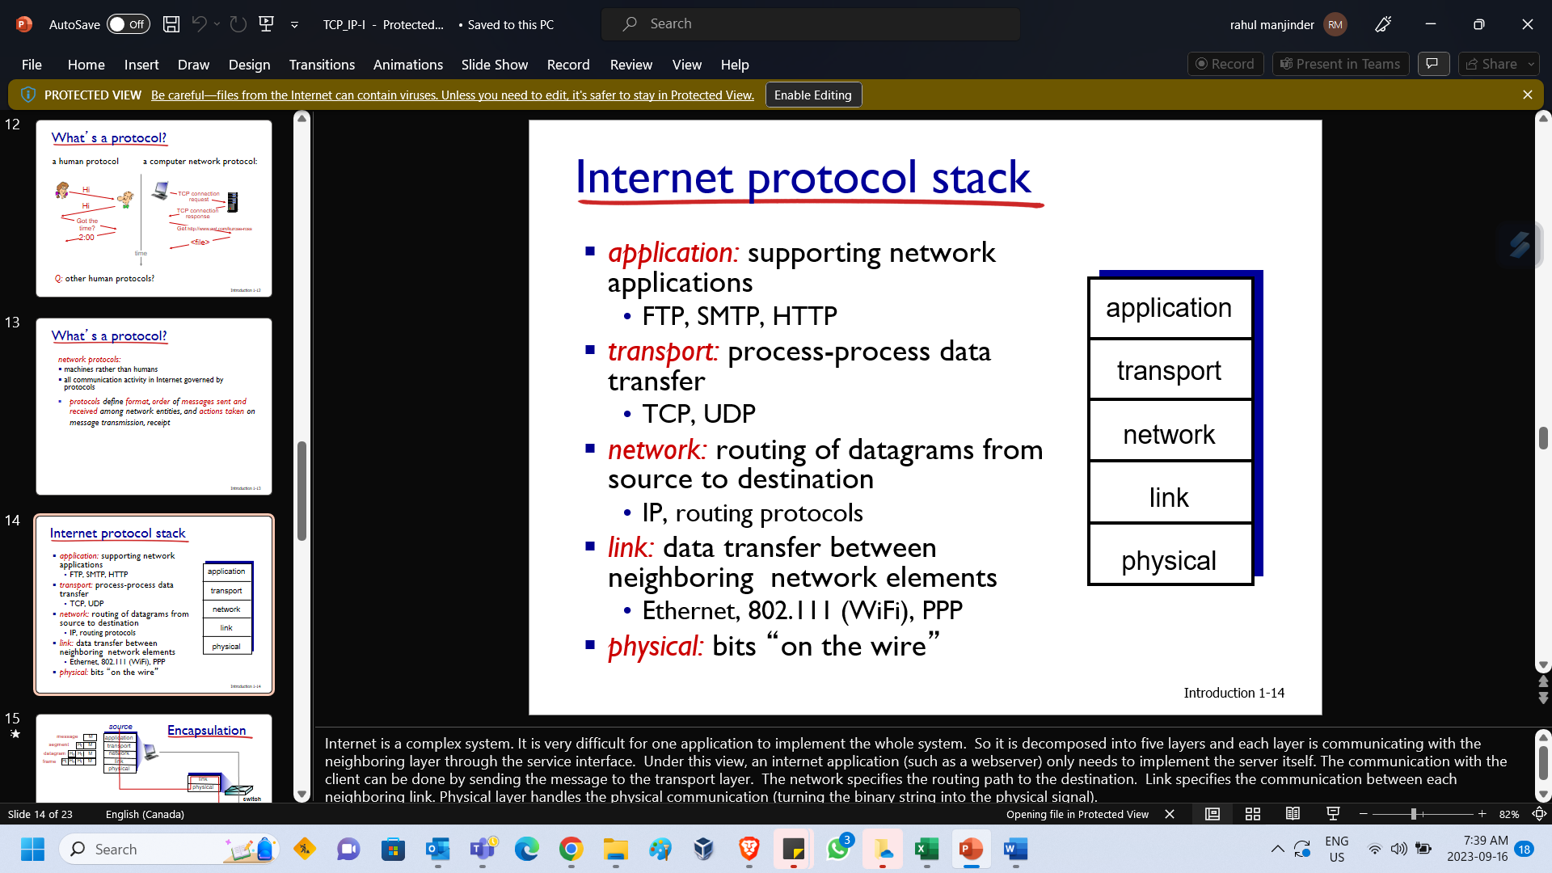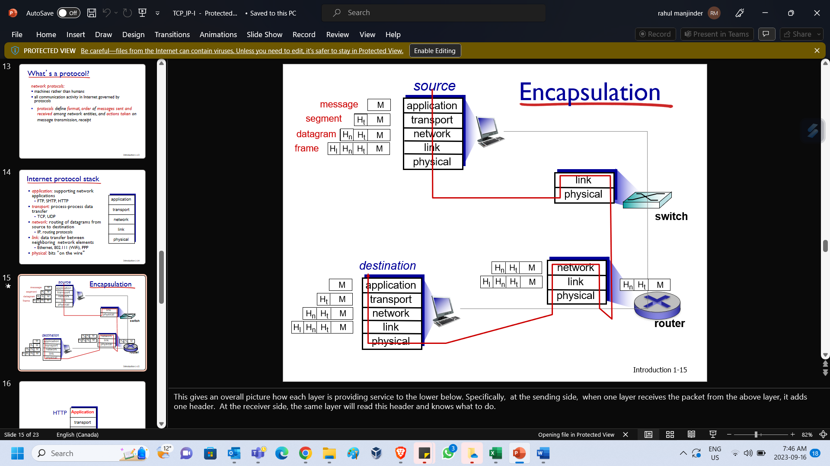

|  |  |
| --- | --- |
| Internet is a complex system. It is very difficult for one application to implement the whole system. So it is decomposed into five layers and each layer is communicating with the neighboring layer through the service interface. Under this view, an internet application (such as a webserver) only needs to implement the server itself. The communication with the client can be done by sending the message to the transport layer. The network specifies the routing path to the destination. Link specifies the communication between each neighboring link. Physical layer handles the physical communication (turning the binary string into the physical signal). | This gives an overall picture how each layer is providing service to the lower below. Specifically, at the sending side, when one layer receives the packet from the above layer, it adds one header. At the receiver side, the same layer will read this header and knows what to do. |

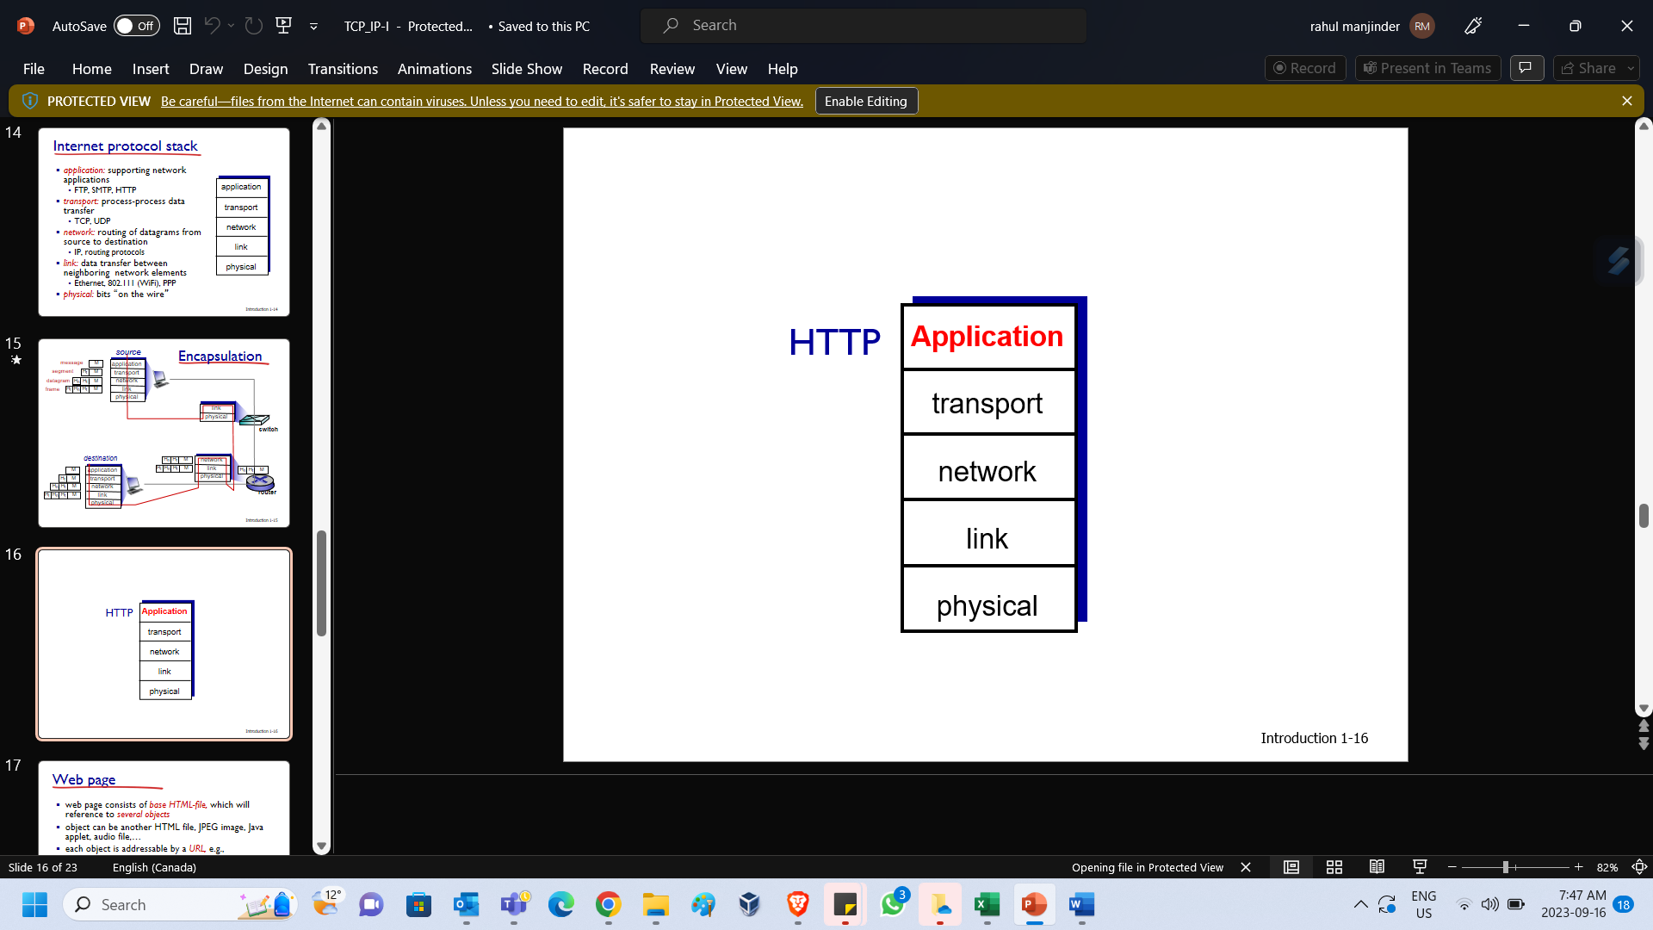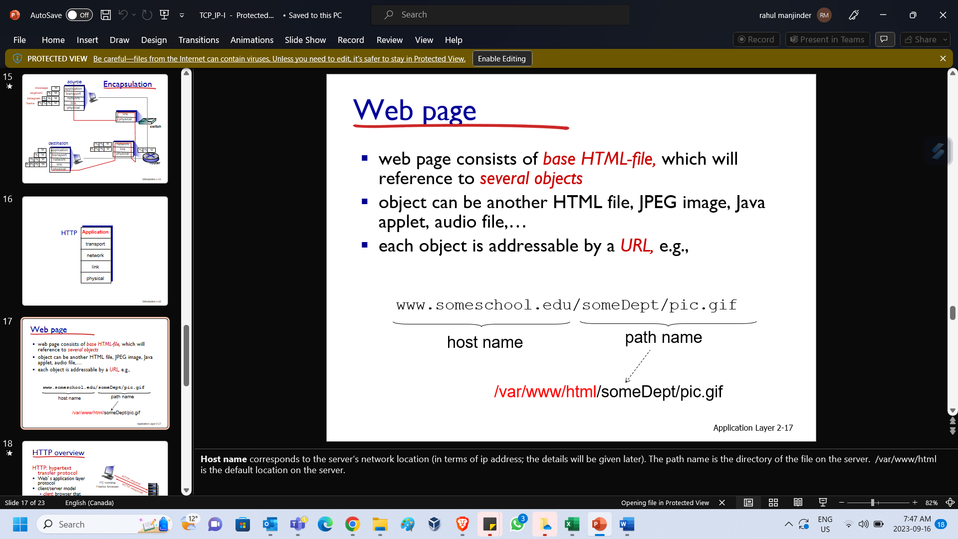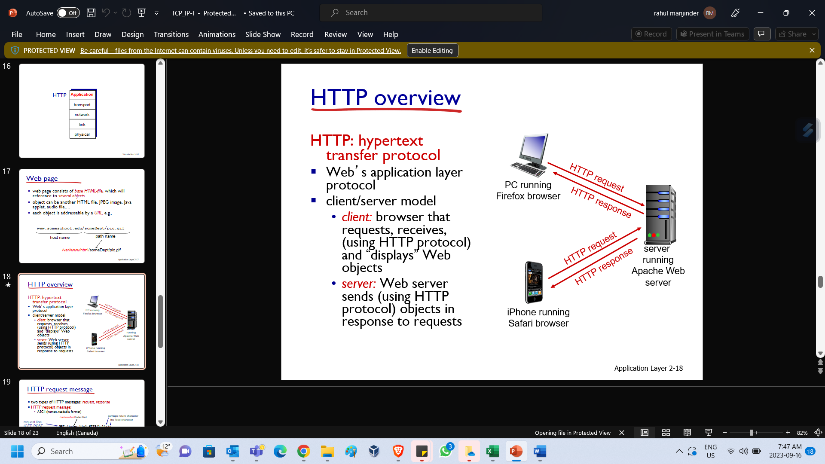

|  |  |  |
| --- | --- | --- |
| **Host name** corresponds to the server’s network location (in terms of IP address; the details will be given later). The path name is the directory of the file on the server. **/var/www/html** is the default location on the server. | This is the http format, send/receive through TCP connection. | When you visit www.google.com, you browser needs to first translate **www.google.com** into its IP address. This is done by **DNS protocol**. DNS is an application layer protocol. |

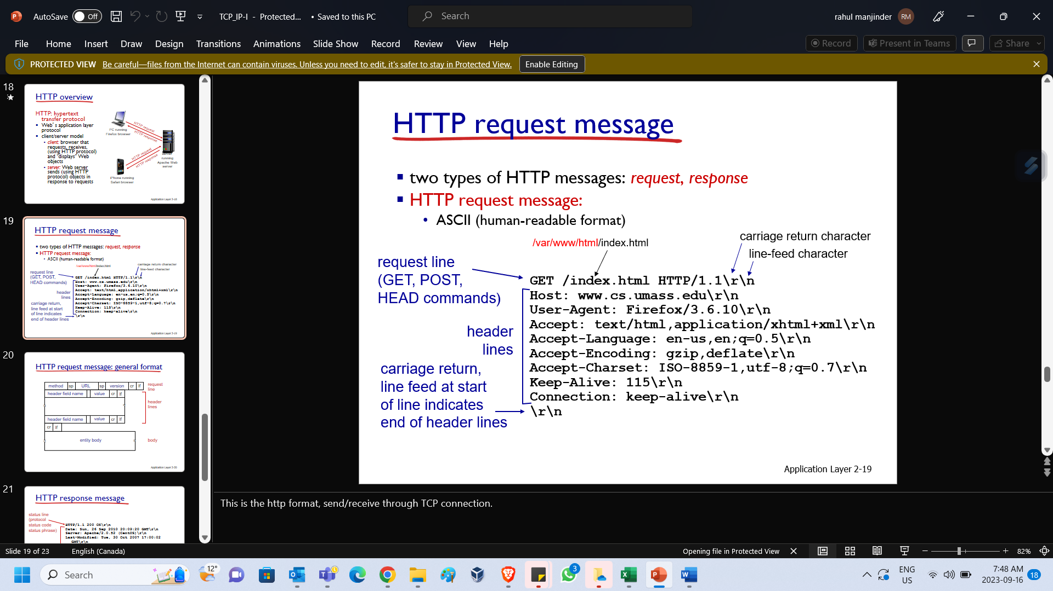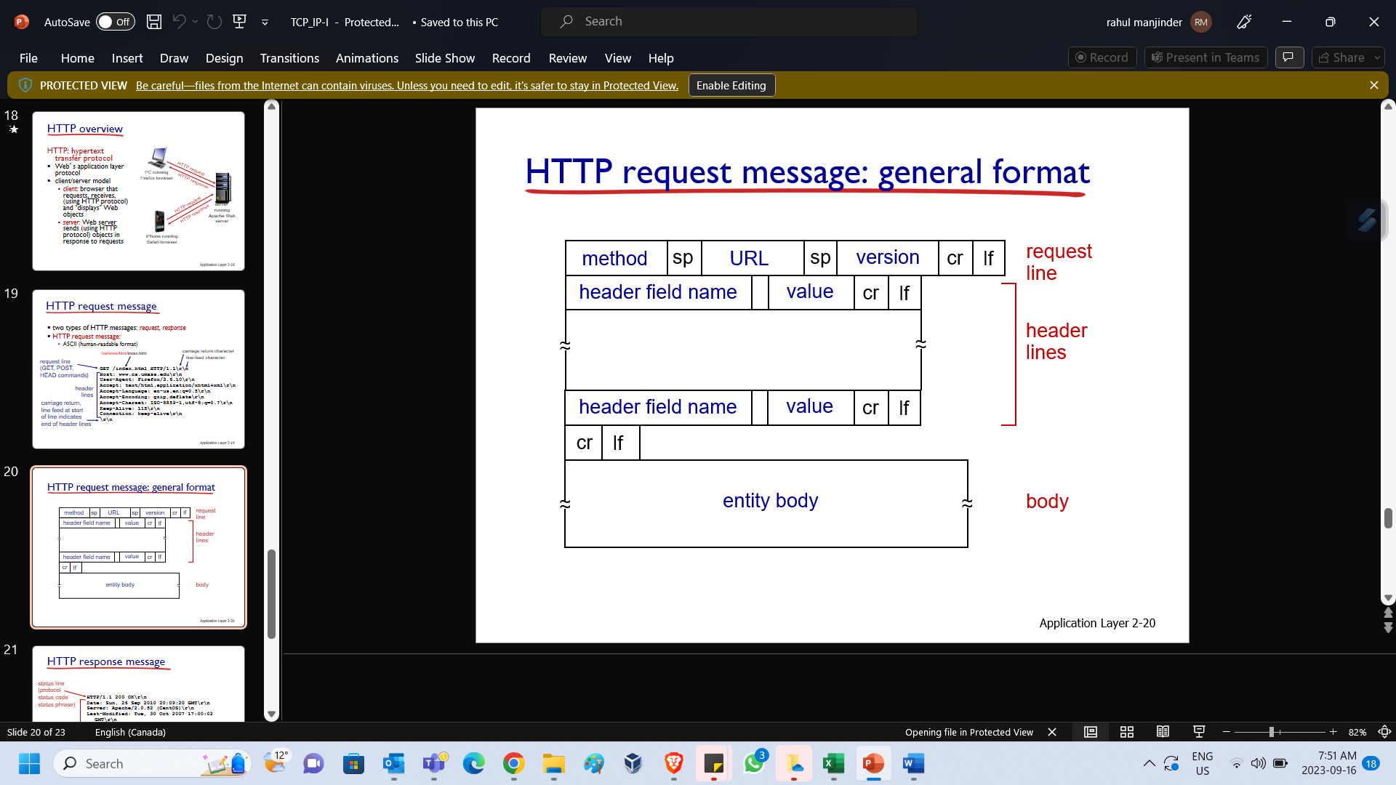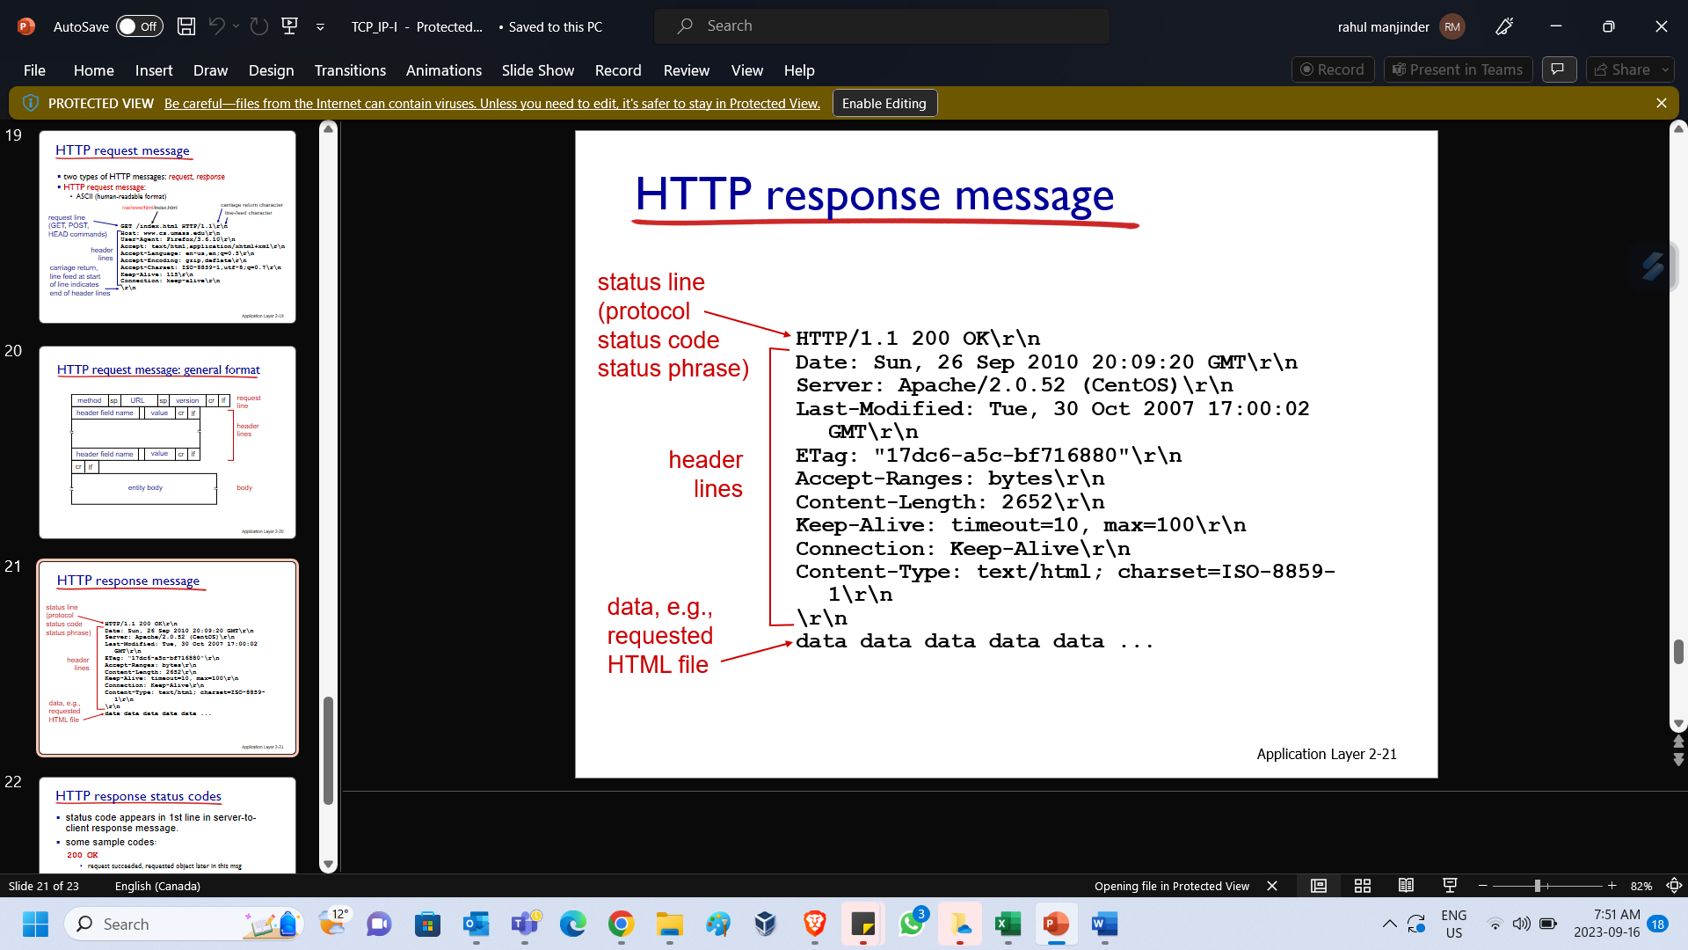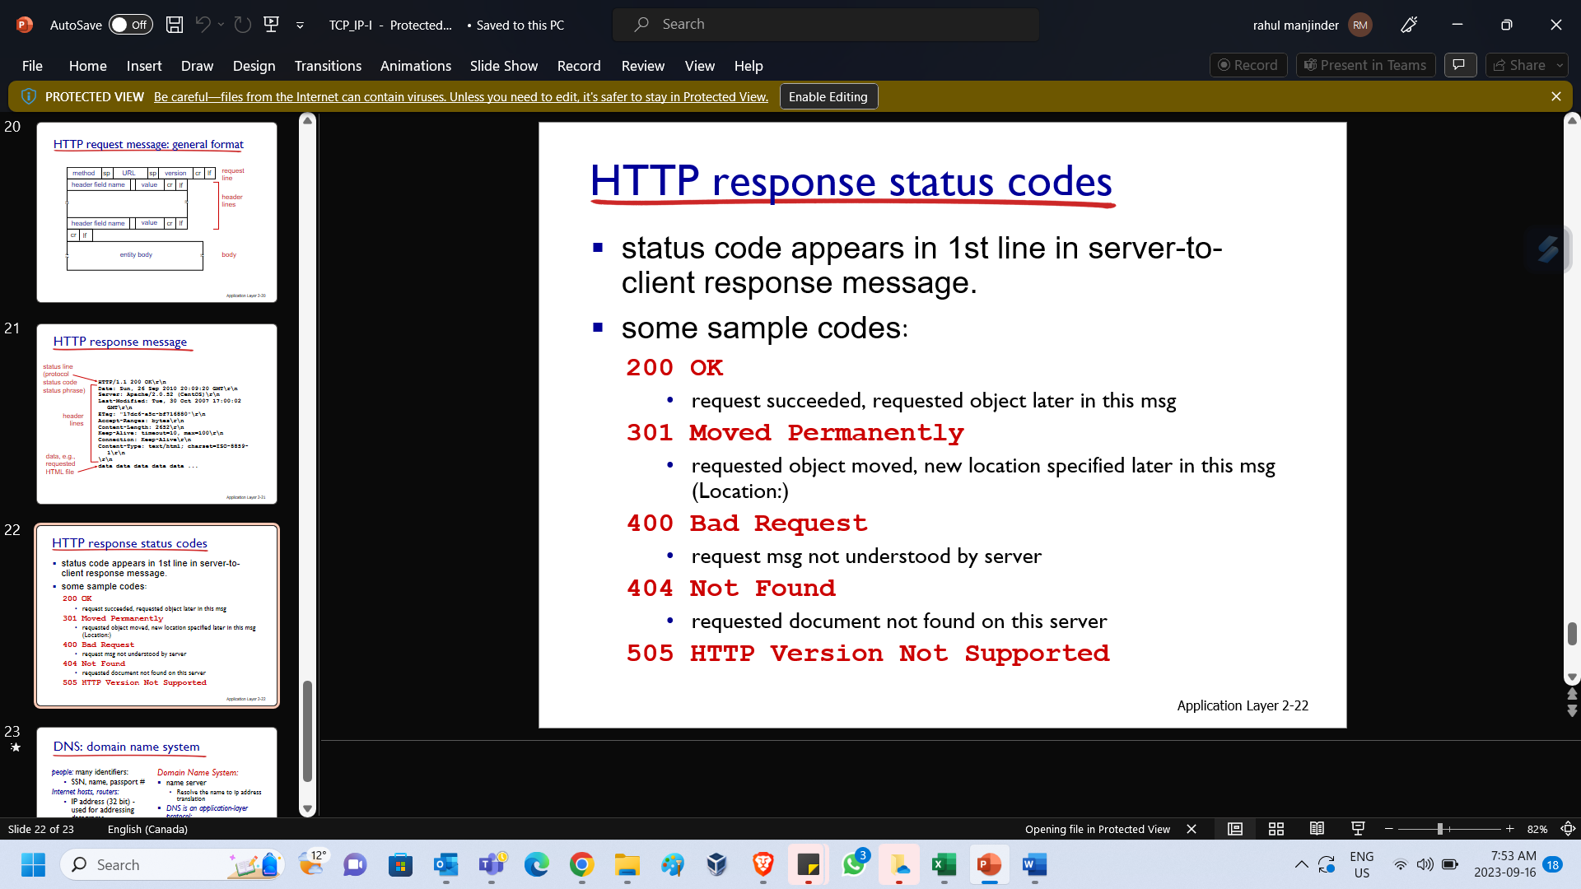

|  |  |
| --- | --- |
|  | When you visit www.google.com, you browser needs to first translate **www.google.com** into its ip address.  This is done by DNS protocol.  DNS is an application layer protocol. |

**Week 2 – Chapter 2 - Introduction to TCP/IP - II**

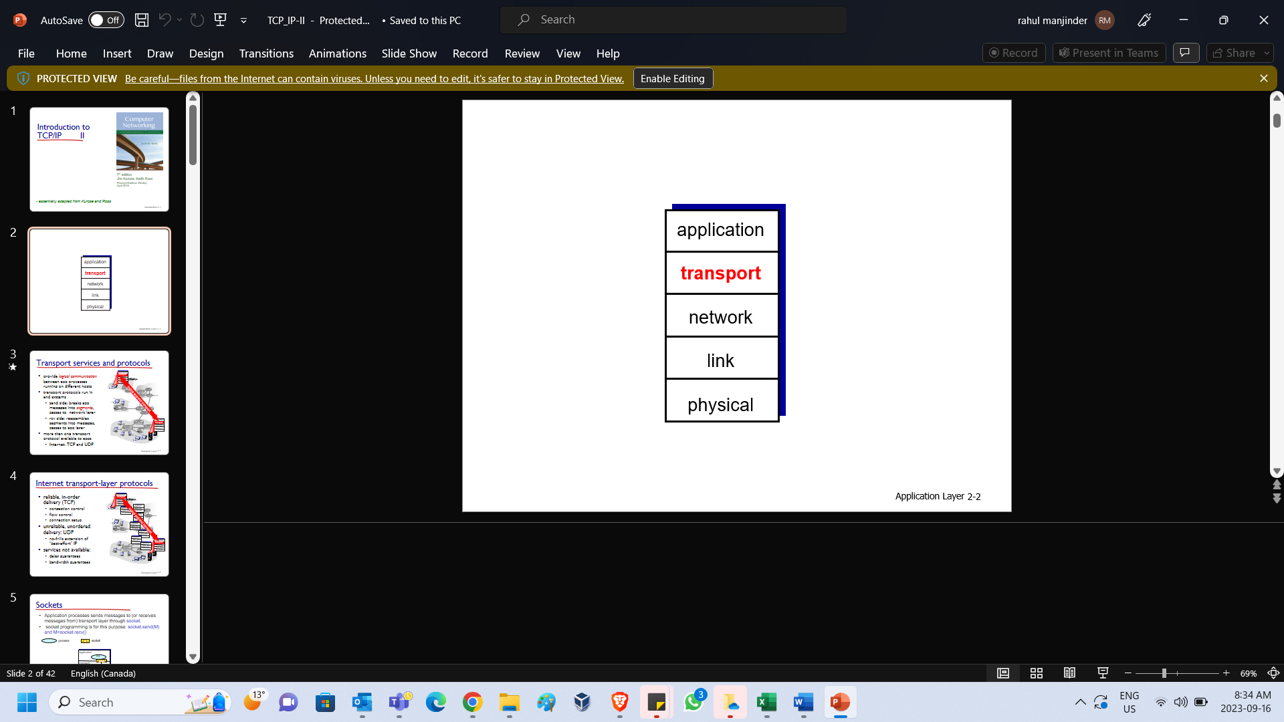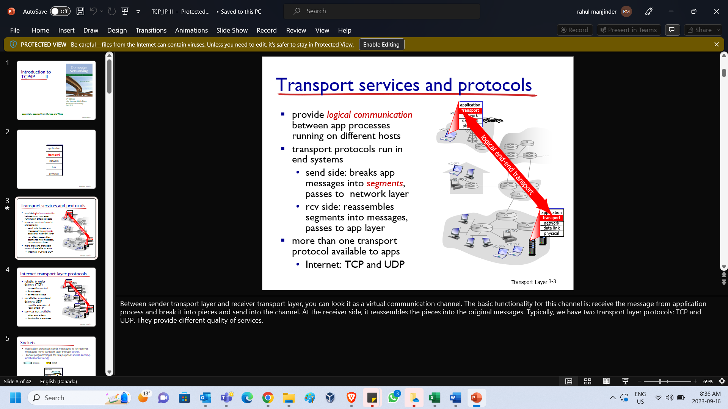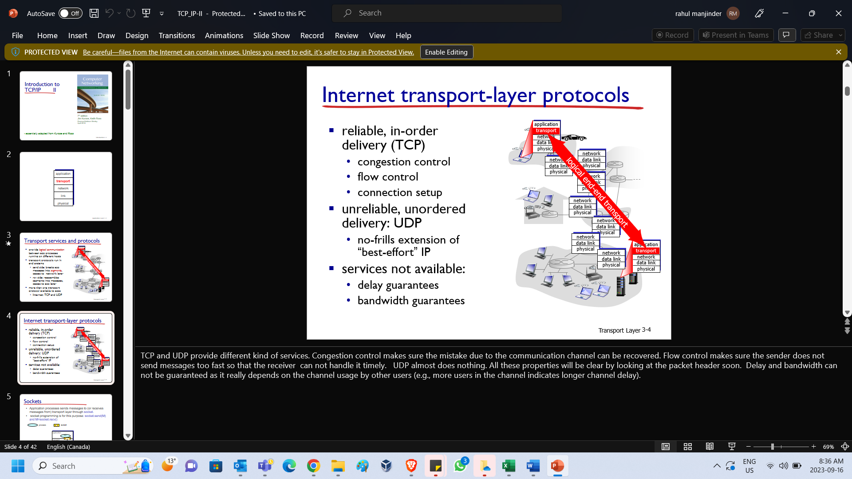

|  |  |
| --- | --- |
| Between sender transport layer and receiver transport layer, you can look it as a virtual communication channel.  The basic functionality for this channel is**: 1.** receive the message from application process and **2.** break it into pieces and **3.** send into the channel.  At the receiver side, it reassembles the pieces into the original messages.  Typically, we have two transport layer protocols: TCP and UDP. They provide different quality of services. | TCP and UDP provide different kind of services. **Congestion control** makes sure the mistake due to the communication channel can be recovered. **Flow control** makes sure the sender does not send messages too fast so that the receiver can not handle it timely.  UDP almost does nothing. All these properties will be clear by looking at the packet header soon. Delay and bandwidth can not be guaranteed as it really depends on the channel usage by other users (e.g., more users in the channel indicates longer channel delay). |

Process is a **running** application. Application process access the transport layer service using socket interfaces: **socket.send()** to send a message and **socket.recv()** to receive a message.

When you run **socket.send(M)**, message M will be put at the sending buffer and is available to transport layer program while you run **M=socket.recv(),** you will retrieve the message M from receive buffer that is delivered by transport layer.

Different application has its own socket and its own send/receive buffer. The transport layer’s job is to **take messages from each application’s buffer** and **add header** and **send out**, at the receiver sends remove headers and place message at the correct receive buffer.

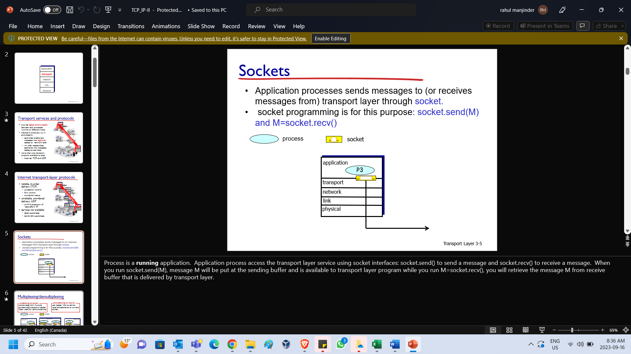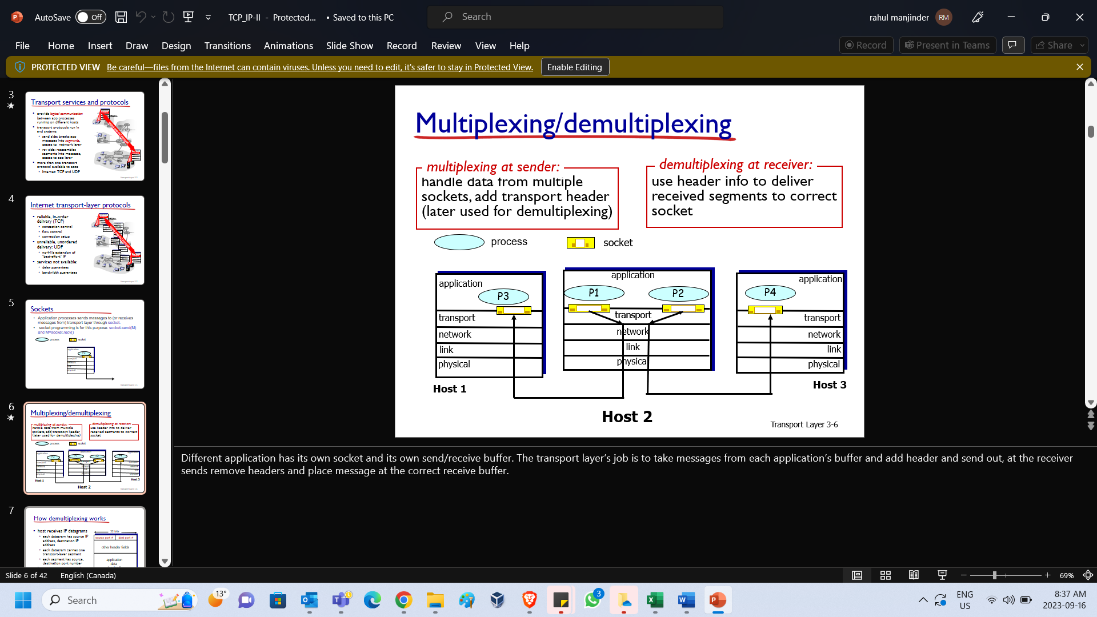

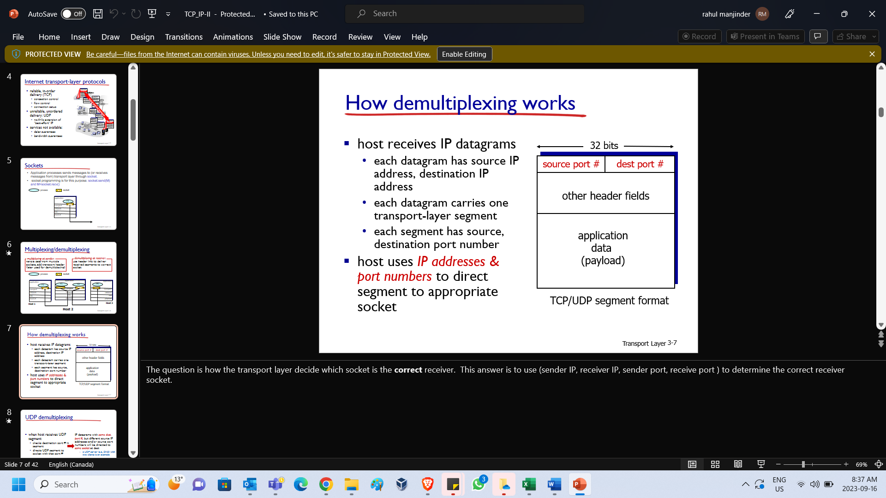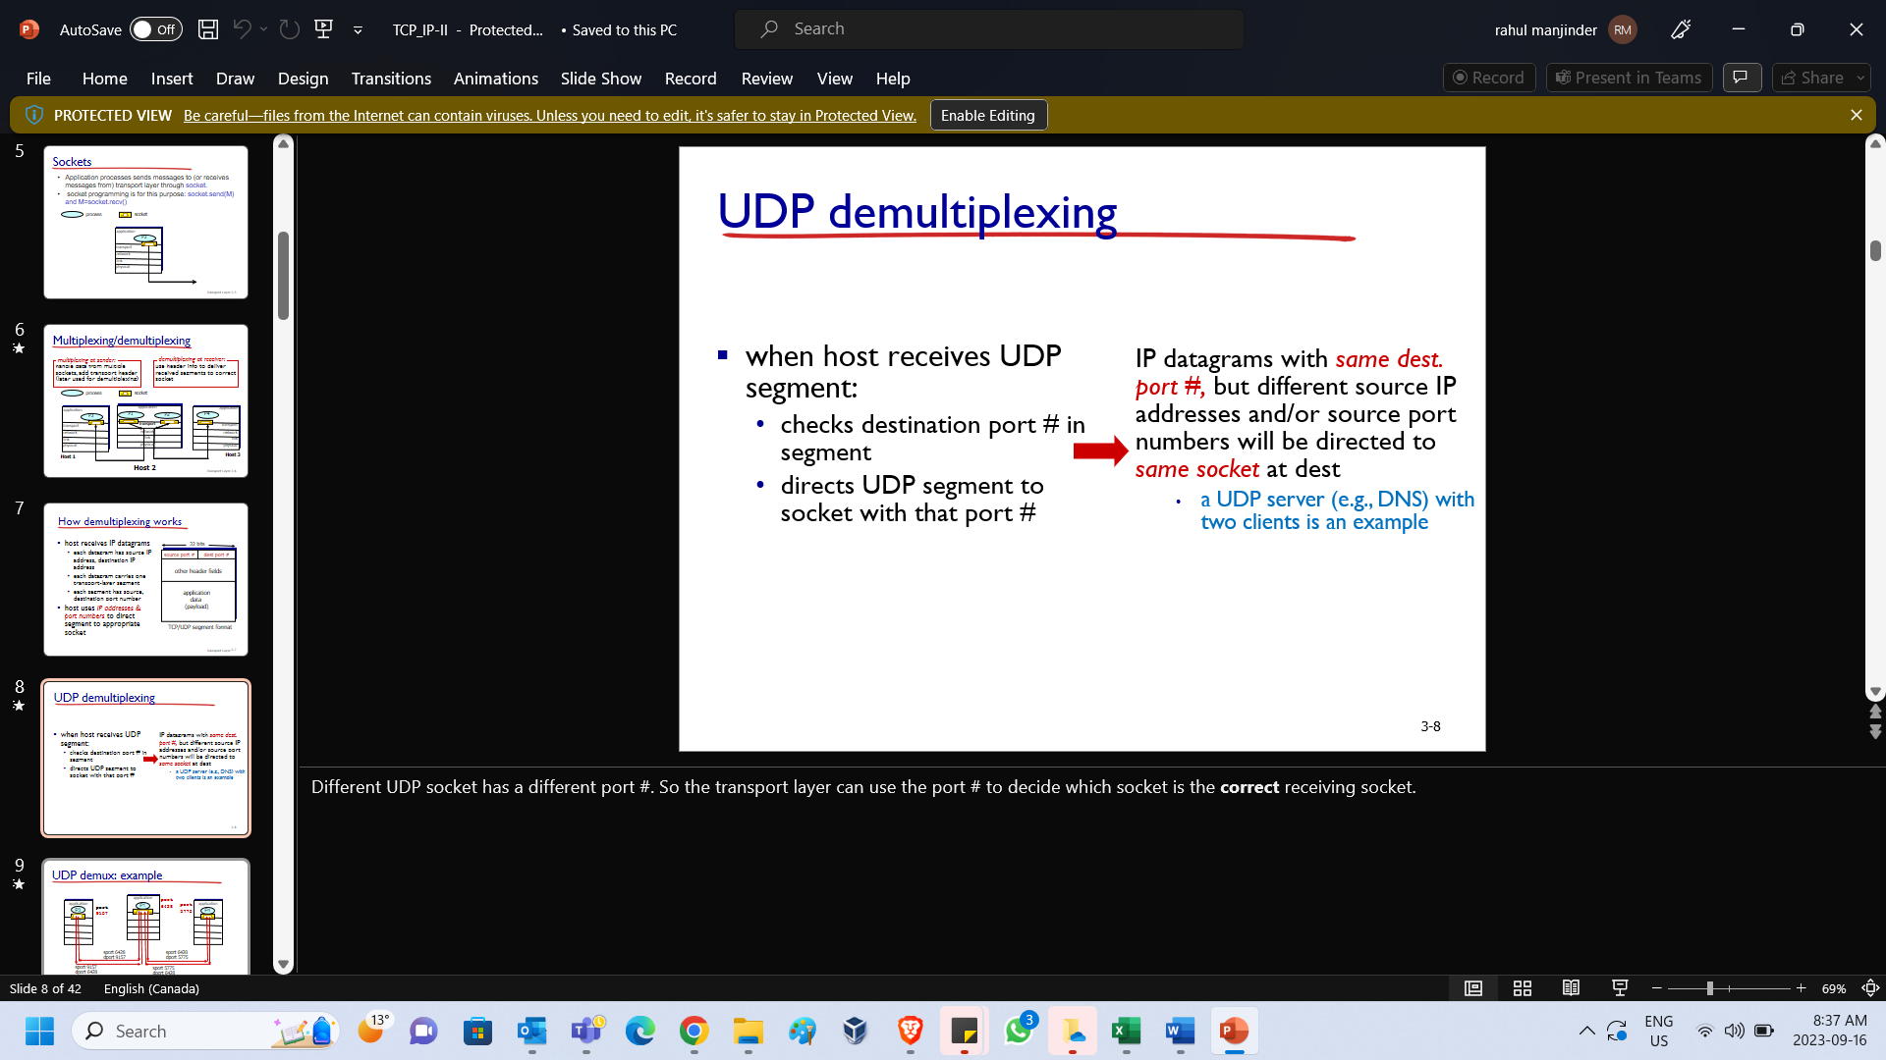

|  |  |  |
| --- | --- | --- |
| The question is how the transport layer decide which socket is the **correct** receiver. This answer is to use (**sender IP, receiver IP, sender port, receive port** ) to determine the correct receiver socket. | Different UDP socket has a different port #. So the transport layer can use the port # to decide which socket is the **correct** receiving socket. | TCP de-multiplexing requires the four tuple. **For example**, HTTP server assigns a **different** socket for each client but all theses socket use the same port 80. So you can not only use port 80 to determine the receiving socket. |

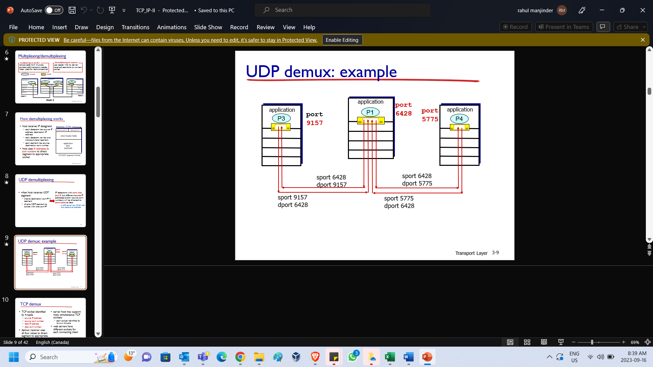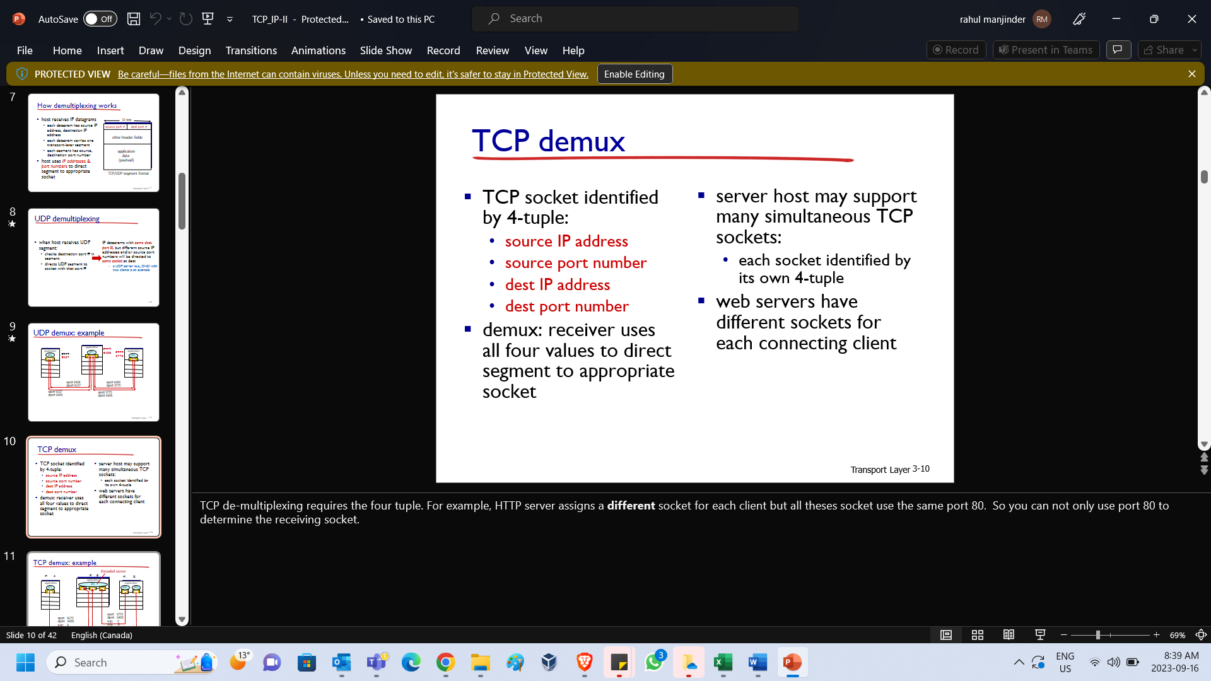

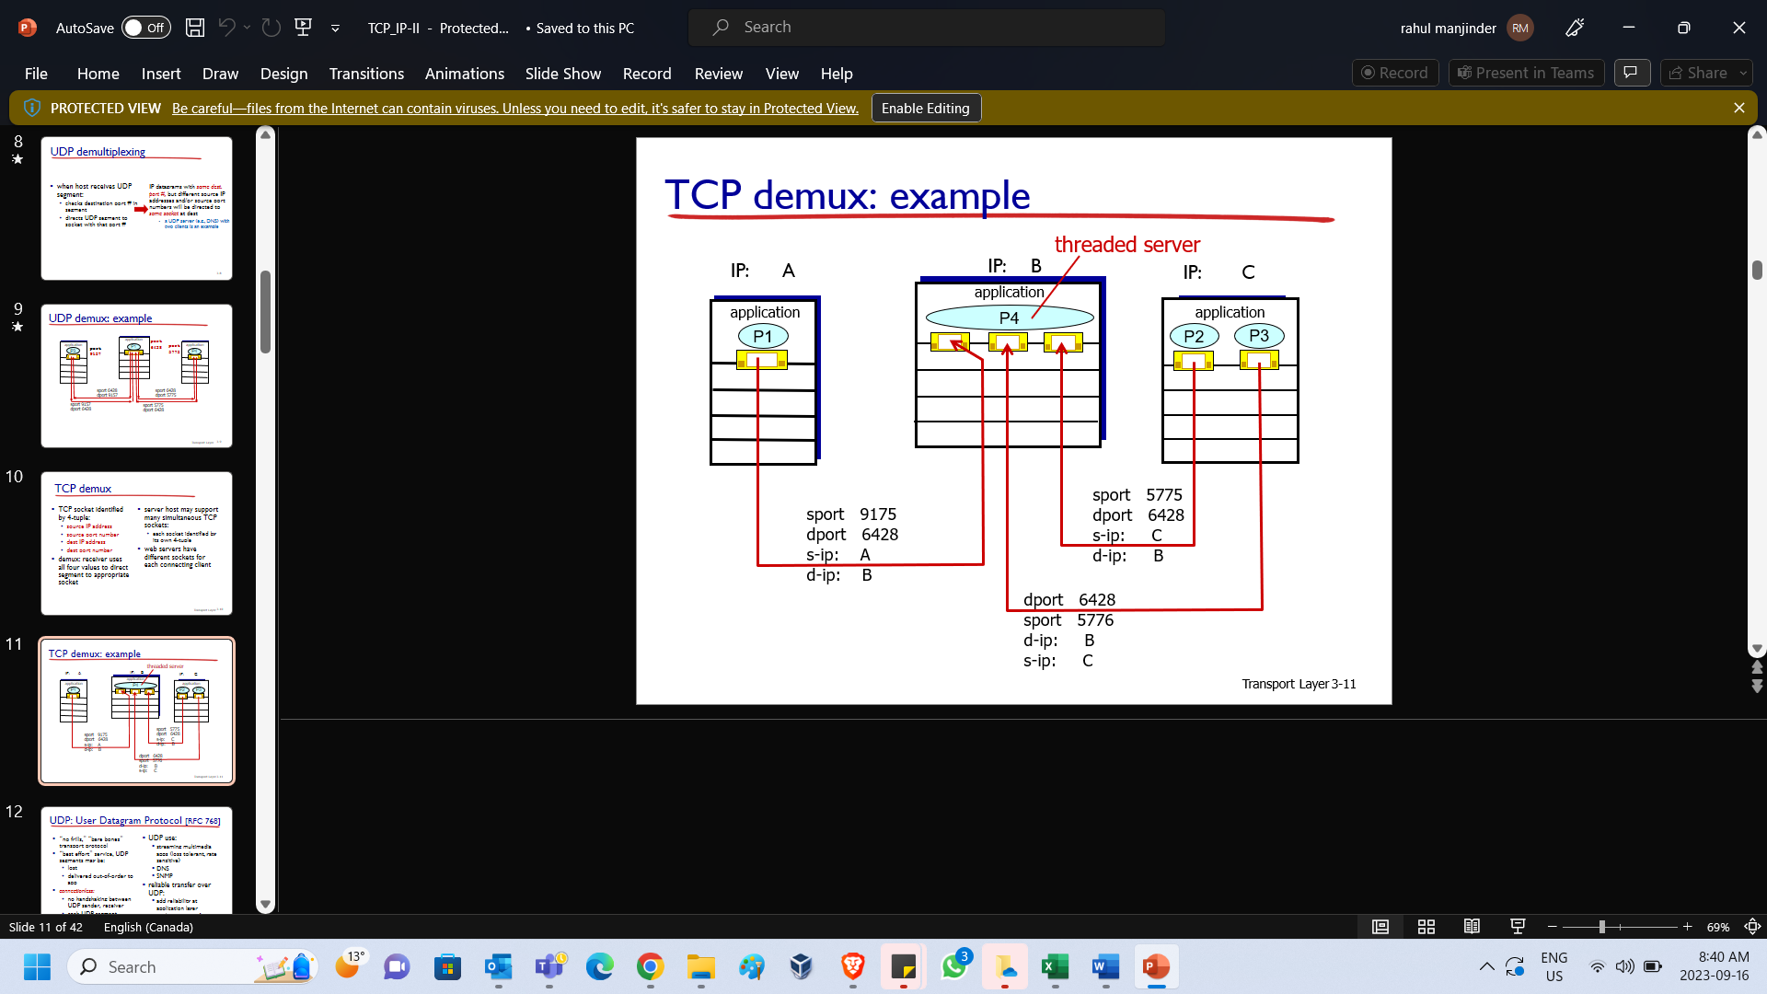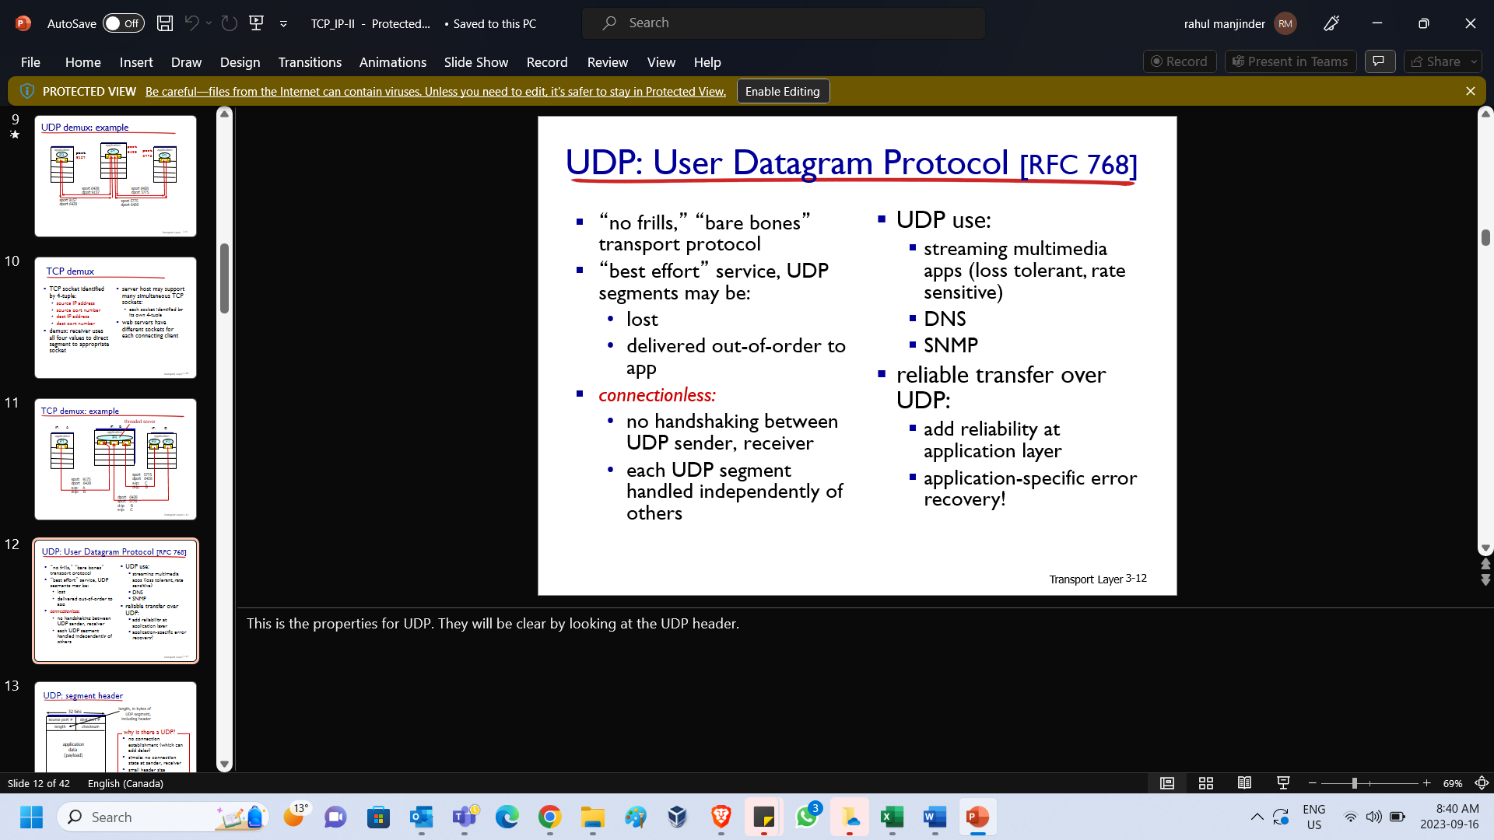

This is the properties for UDP. They will be clear by looking at the UDP header.

Now you can check why the UDP has the properties mentioned before:

* **connectionless**, because no field is concerned with connection;
* **could be lost or out of order**: no field to recover the sending order
* **no error correction**: no field is used to correct error.

UDP checksum is used to **detect** error but not **correct** error. The sender calculates the checksum put it in the UDP header; the receiver recalculates the checksum to verify if it matches the checksum in UDP header. If the packet has error, the checksum should be different. **Detection** is quite different from **correction**. It is quite similar to the scenario: You can easily verify someone’s solution to a problem is wrong but you do not know how to correct.

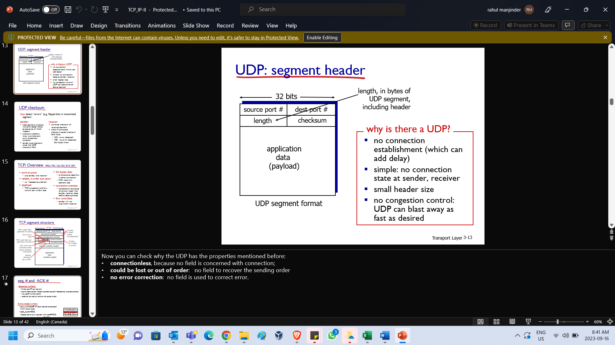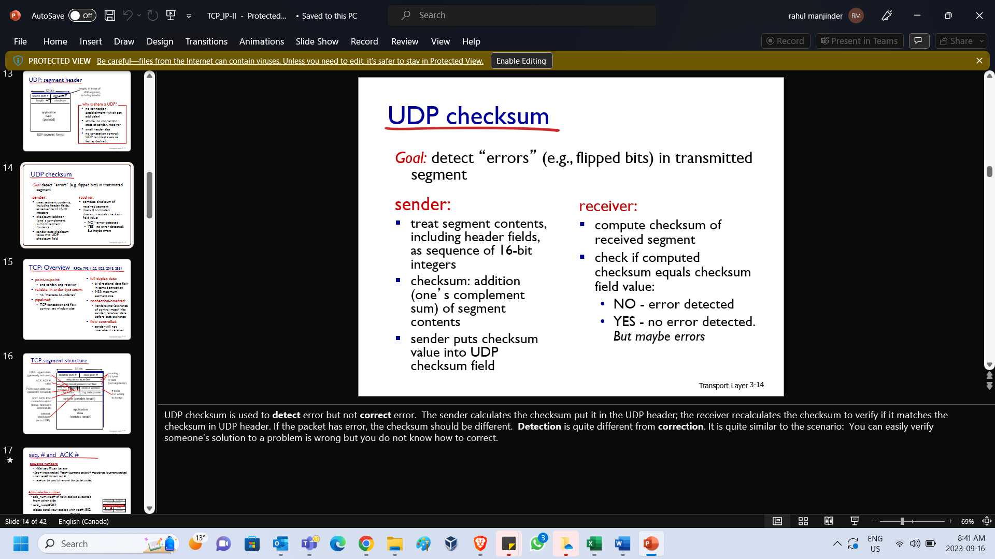

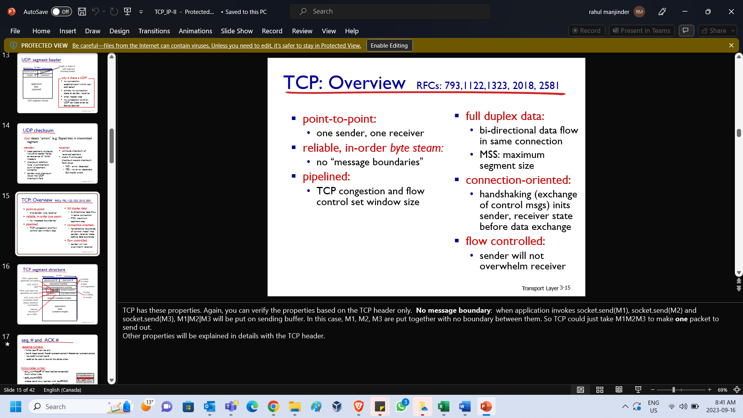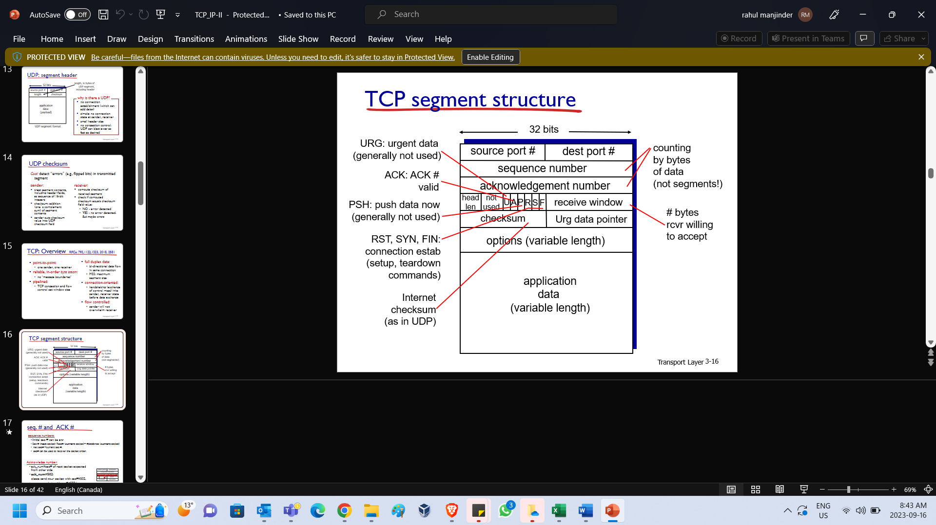

TCP has these properties. Again, you can verify the properties based on the TCP header only. **No message boundary**: when application invokes socket.send(M1), socket.send(M2) and socket.send(M3), M1|M2|M3 will be put on sending buffer. In this case, M1, M2, M3 are put together with no boundary between them. So TCP could just take M1M2M3 to make **one** packet to send out.

Other properties will be explained in details with the TCP header.

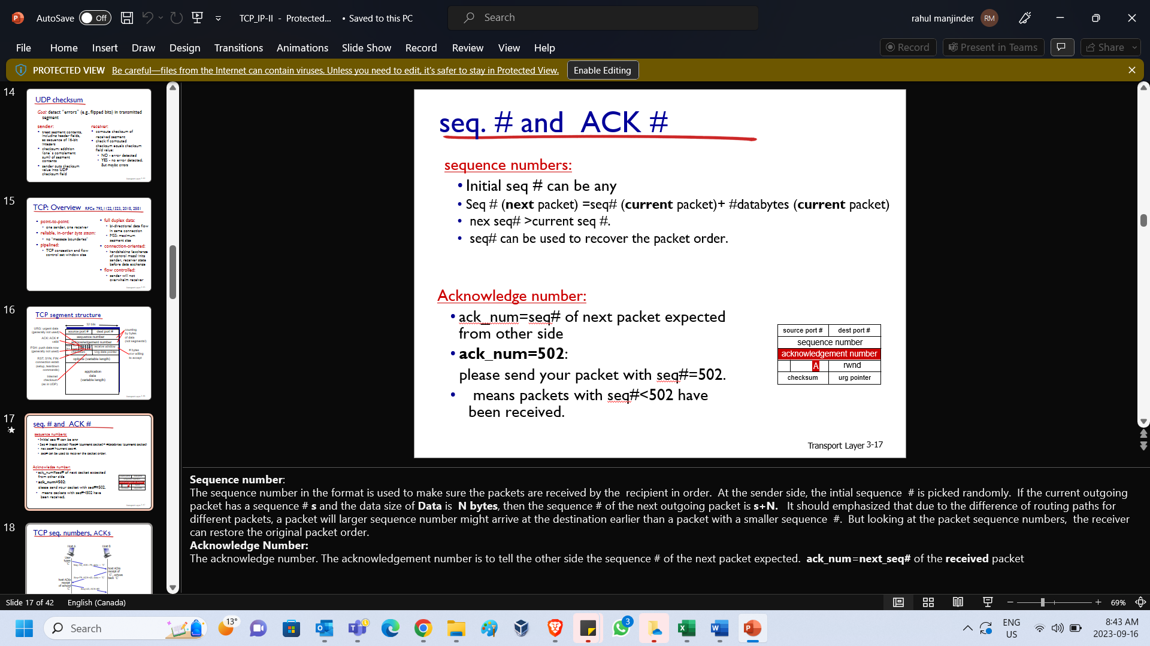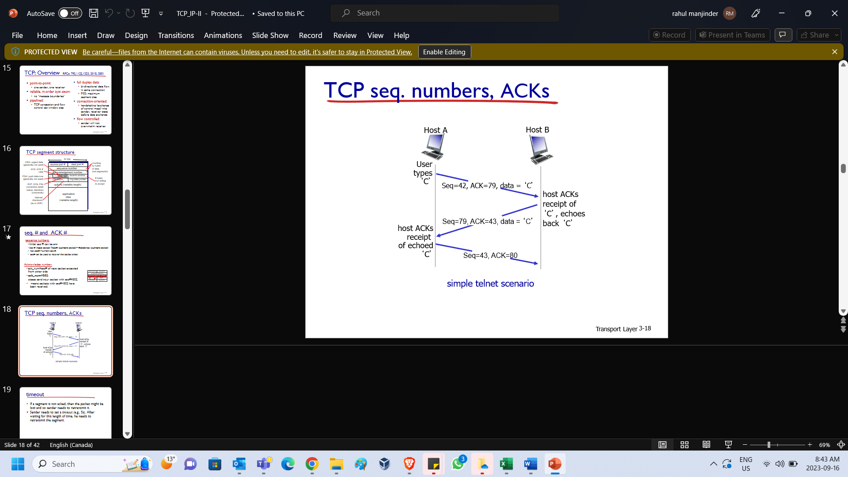

**Sequence number**: The sequence number in the format is used to make sure the packets are received by the recipient in order. At the sender side, the intial sequence # is picked randomly. If the current outgoing packet has a sequence # **s** and the data size of **Data** is **N bytes**, then the sequence # of the next outgoing packet is **s+N.** It should emphasized that due to the difference of routing paths for different packets, a packet will larger sequence number might arrive at the destination earlier than a packet with a smaller sequence #. But looking at the packet sequence numbers, the receiver can restore the original packet order.

**Acknowledge Number:** The acknowledge number. The acknowledgement number is to tell the other side the sequence # of the next packet expected. **ack_num**=**next_seq#** of the **received** packet

|  |  |
| --- | --- |
|  | If the segment is lost in the transmission, the sender has to retransmit the packet (to maintain the reliability).  **Ques.** : How can the sender realize that the packet is lost?  **Ans.** The answer is timeout.  You set a timeout when sending out a packet. When the acknowledgement is not returned after timeout, you can think it is lost (even if it actually is not) and do the retransmission. |

When a packet arrives at IP layer, IP layer processes it and removes the IP header. This results in the TCP segment and will be given to transport layer. Transport layers then processes this segment and removes the TCP header and delivers the resulting application data to TCP socket at socket’s receive buffer. When application program wants to read data from socket. It invokes read function such as recv() to get it. In this case, the data will be removed from buffer. It is possible that the reading speed is slower than the delivering speed. In this case, the receive buffer will overflow. So we need a flow control to tell the sender to slow down the transmission. The **receive_window** field in TCP header in the packet replying the sender is for this purpose.

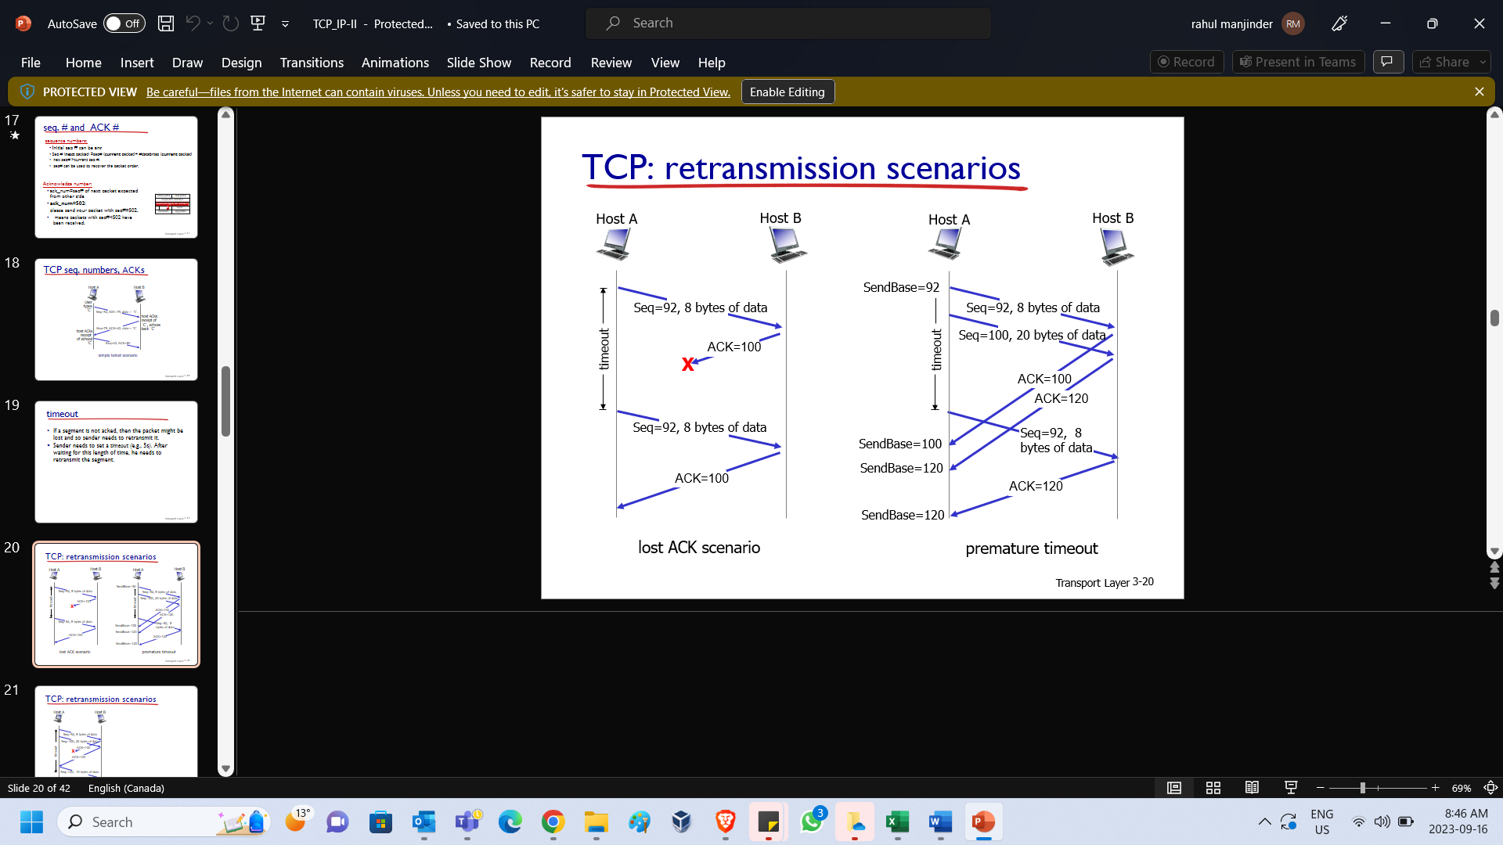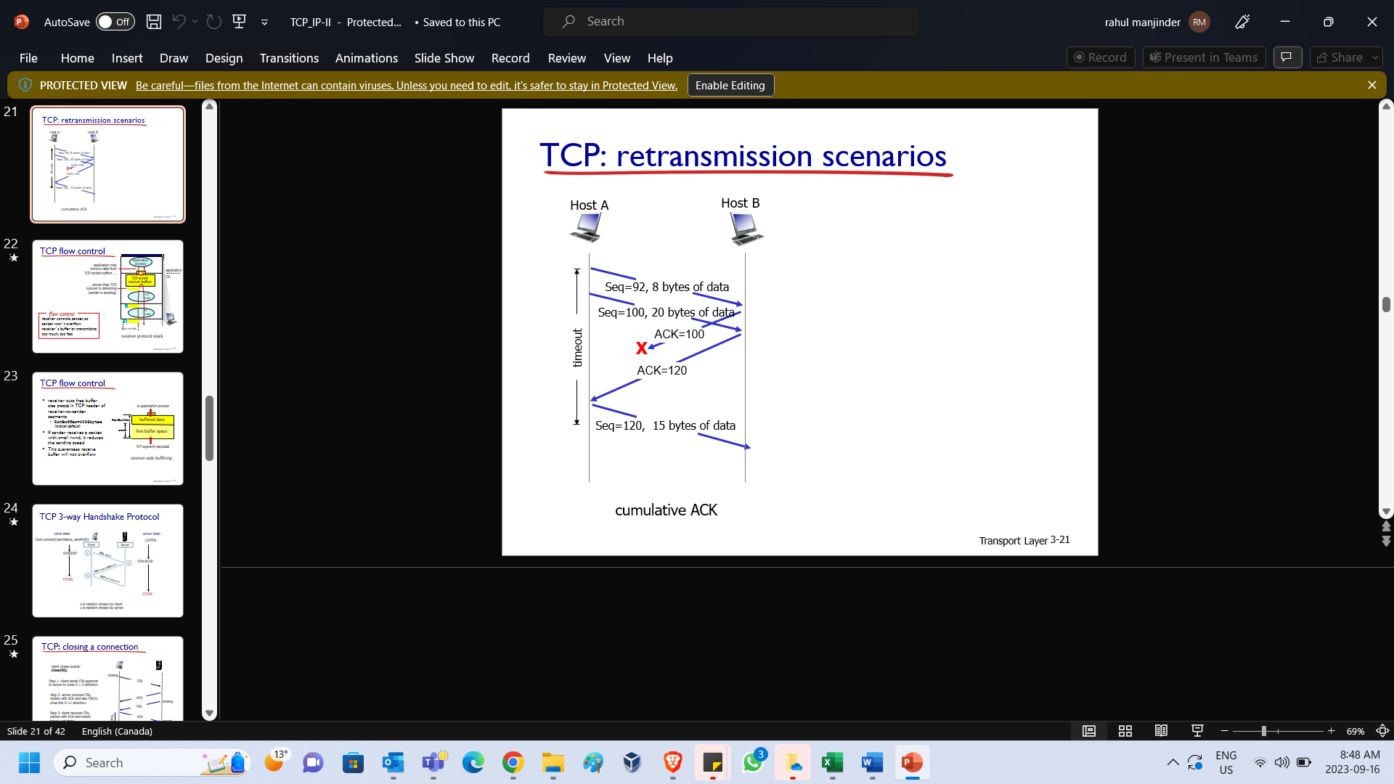

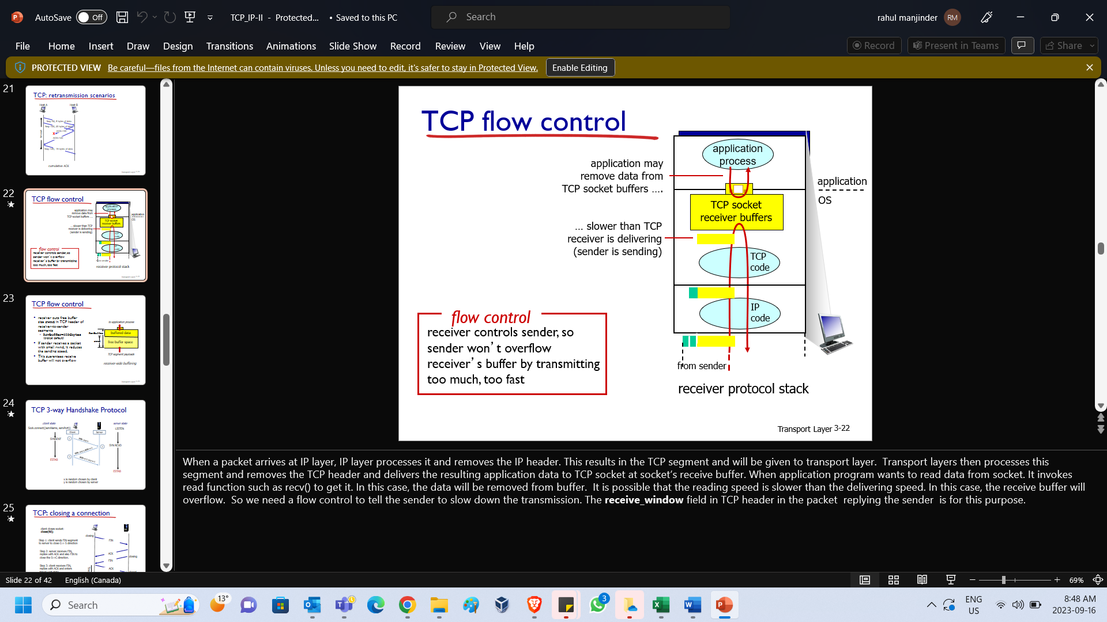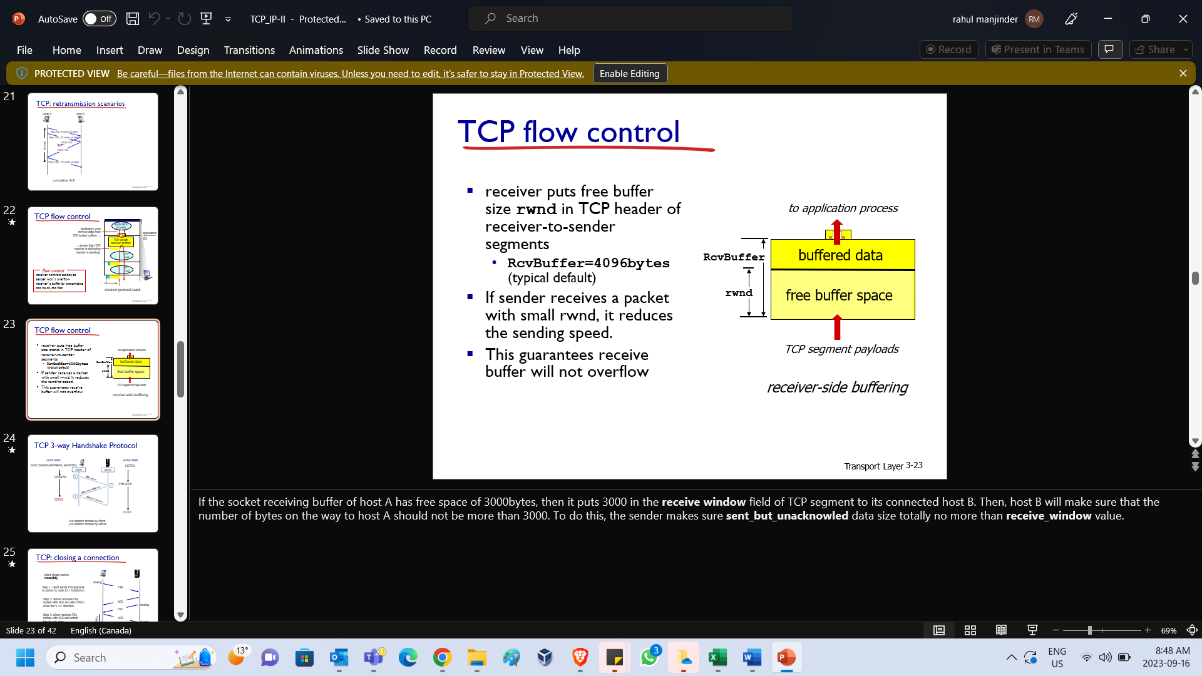

If the socket receiving buffer of host A has free space of 3000bytes, then it puts 3000 in the **receive window** field of TCP segment to its connected host B. Then, host B will make sure that the number of bytes on the way to host A should not be more than 3000. To do this, the sender makes sure **sent_but_unacknowled** data size totally no more than **receive_window** value.

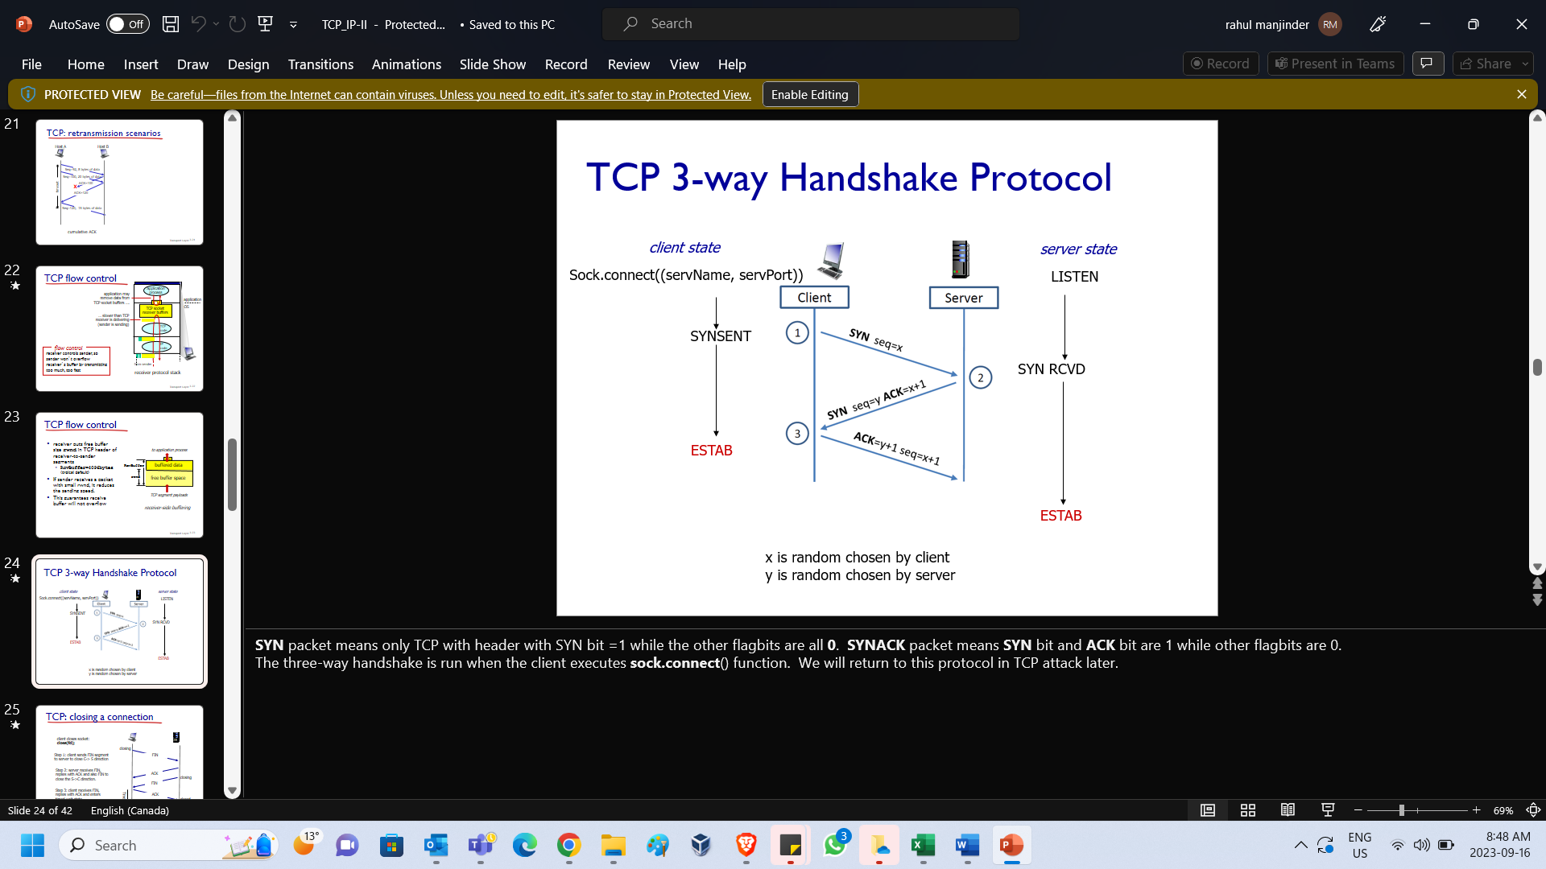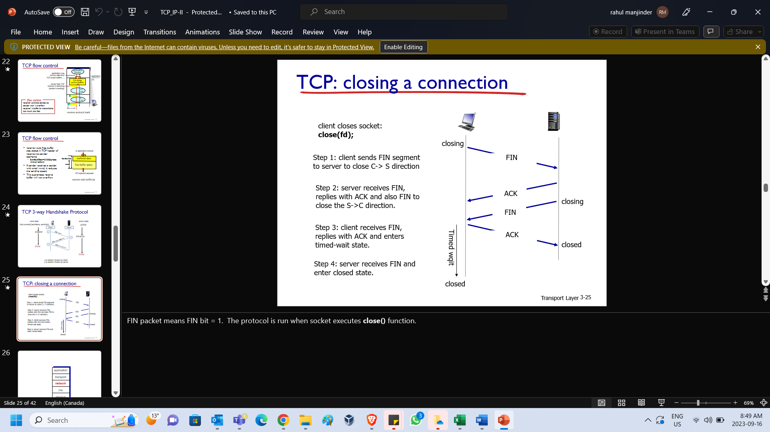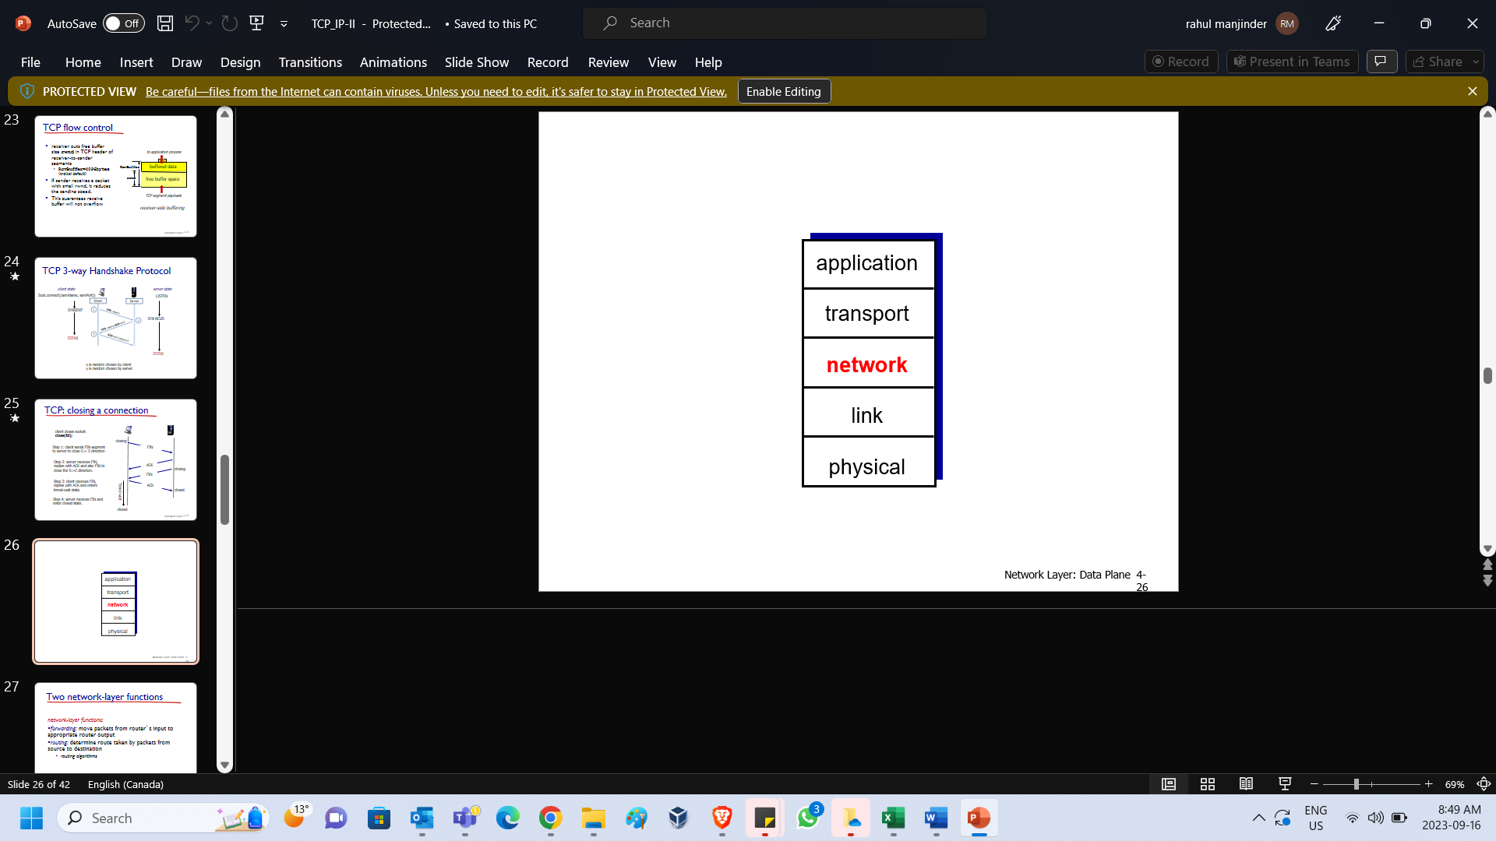

|  |  |
| --- | --- |
| **SYN** packet means only TCP with header with SYN bit =1 while the other flagbits are all **0**.  **SYNACK** packet means **SYN** bit and **ACK** bit are 1 while other flagbits are 0.  The three-way handshake is run when the client executes **sock.connect**() function.  We will return to this protocol in TCP attack later. | FIN packet means FIN bit = 1. The protocol is run when socket executes **close()** function. |

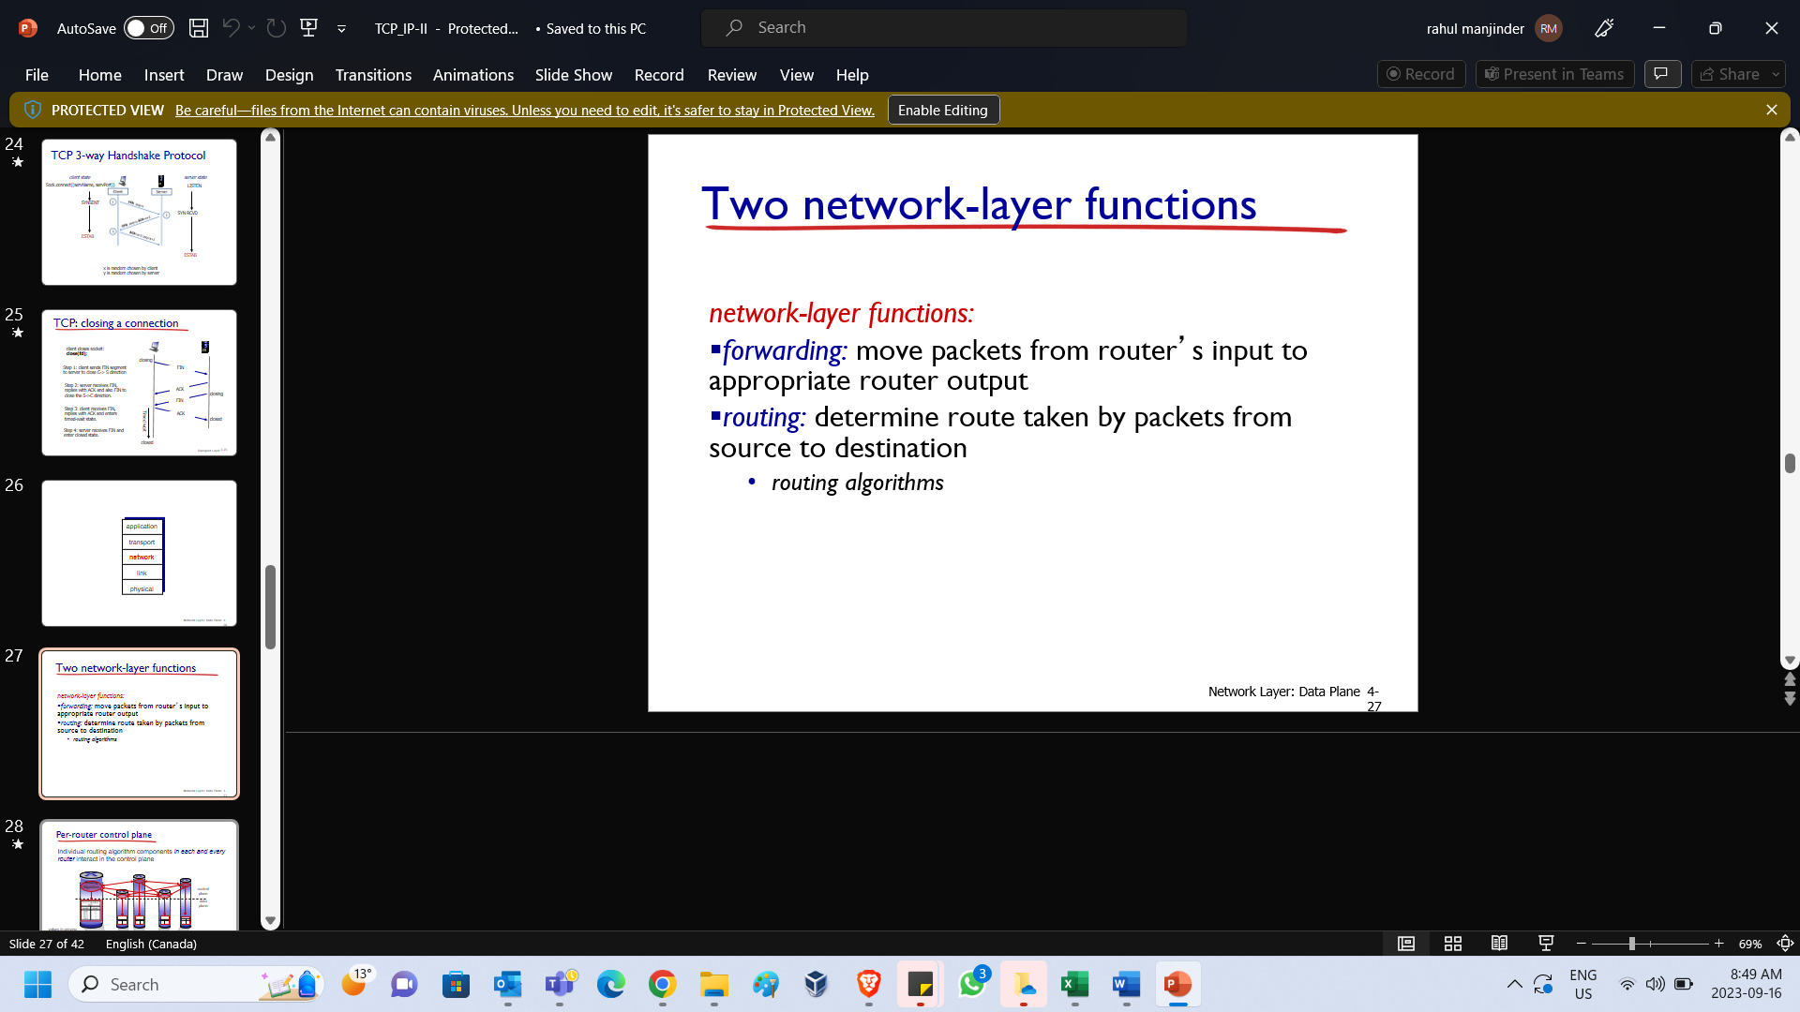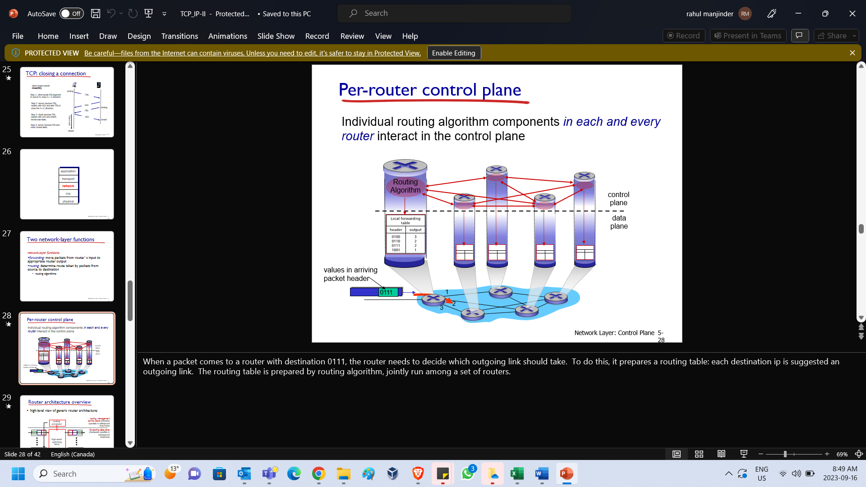

|  |  |  |
| --- | --- | --- |
| When a packet comes to a router with destination **0111**, the router needs to decide which outgoing link should take. To do this, it prepares a **routing table**: each destination ip is suggested an outgoing link. The routing table is prepared by routing algorithm, jointly run among a set of routers. | This is the architecture of a router, consisting of input ports, output ports and switching fabric controlled by routing processor. Input port takes in the incoming packet and output port sends out the outgoing packet. The switching fabric, under the routing processor control, shifts the packet at input port to the designated output port. | Input port has three parts:  **1. Line termination unit**: deal with the physical layer processing, converting the physical signal into bit strings.  **2. Link lay protocol**: deal with the link layer processing (to be detailed in the next lecture)  **3. Lookup and forwarding:** This looks up the routing table to find out which output link should the packet be moved to and then move to that port. The routing table could be destination-based, or, generalized rule based (which consider other fields such as dest port # in the packet header). |

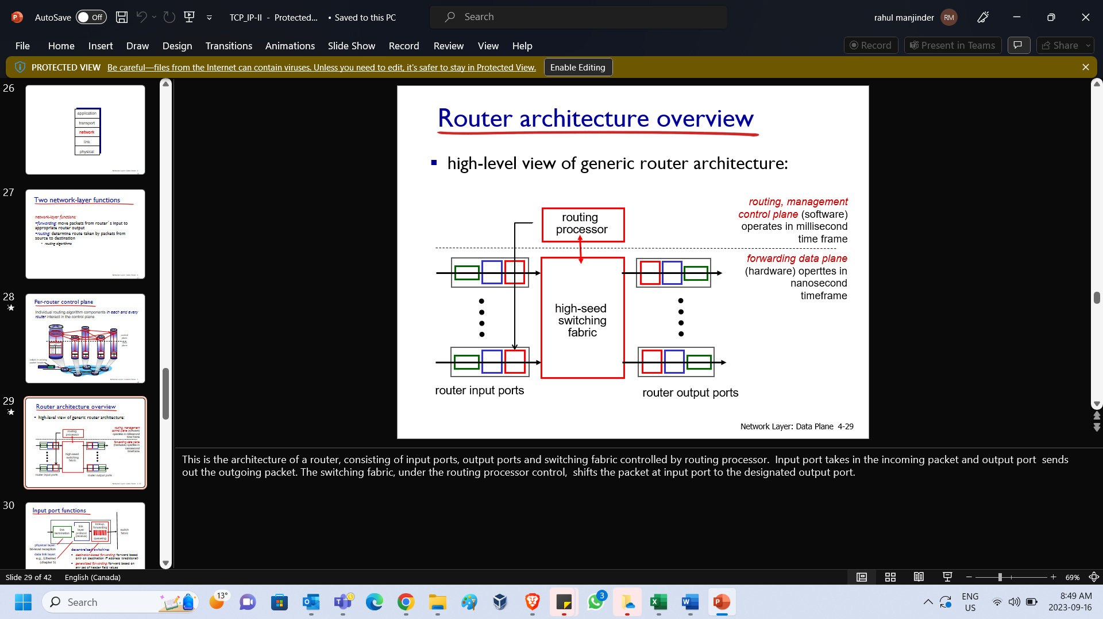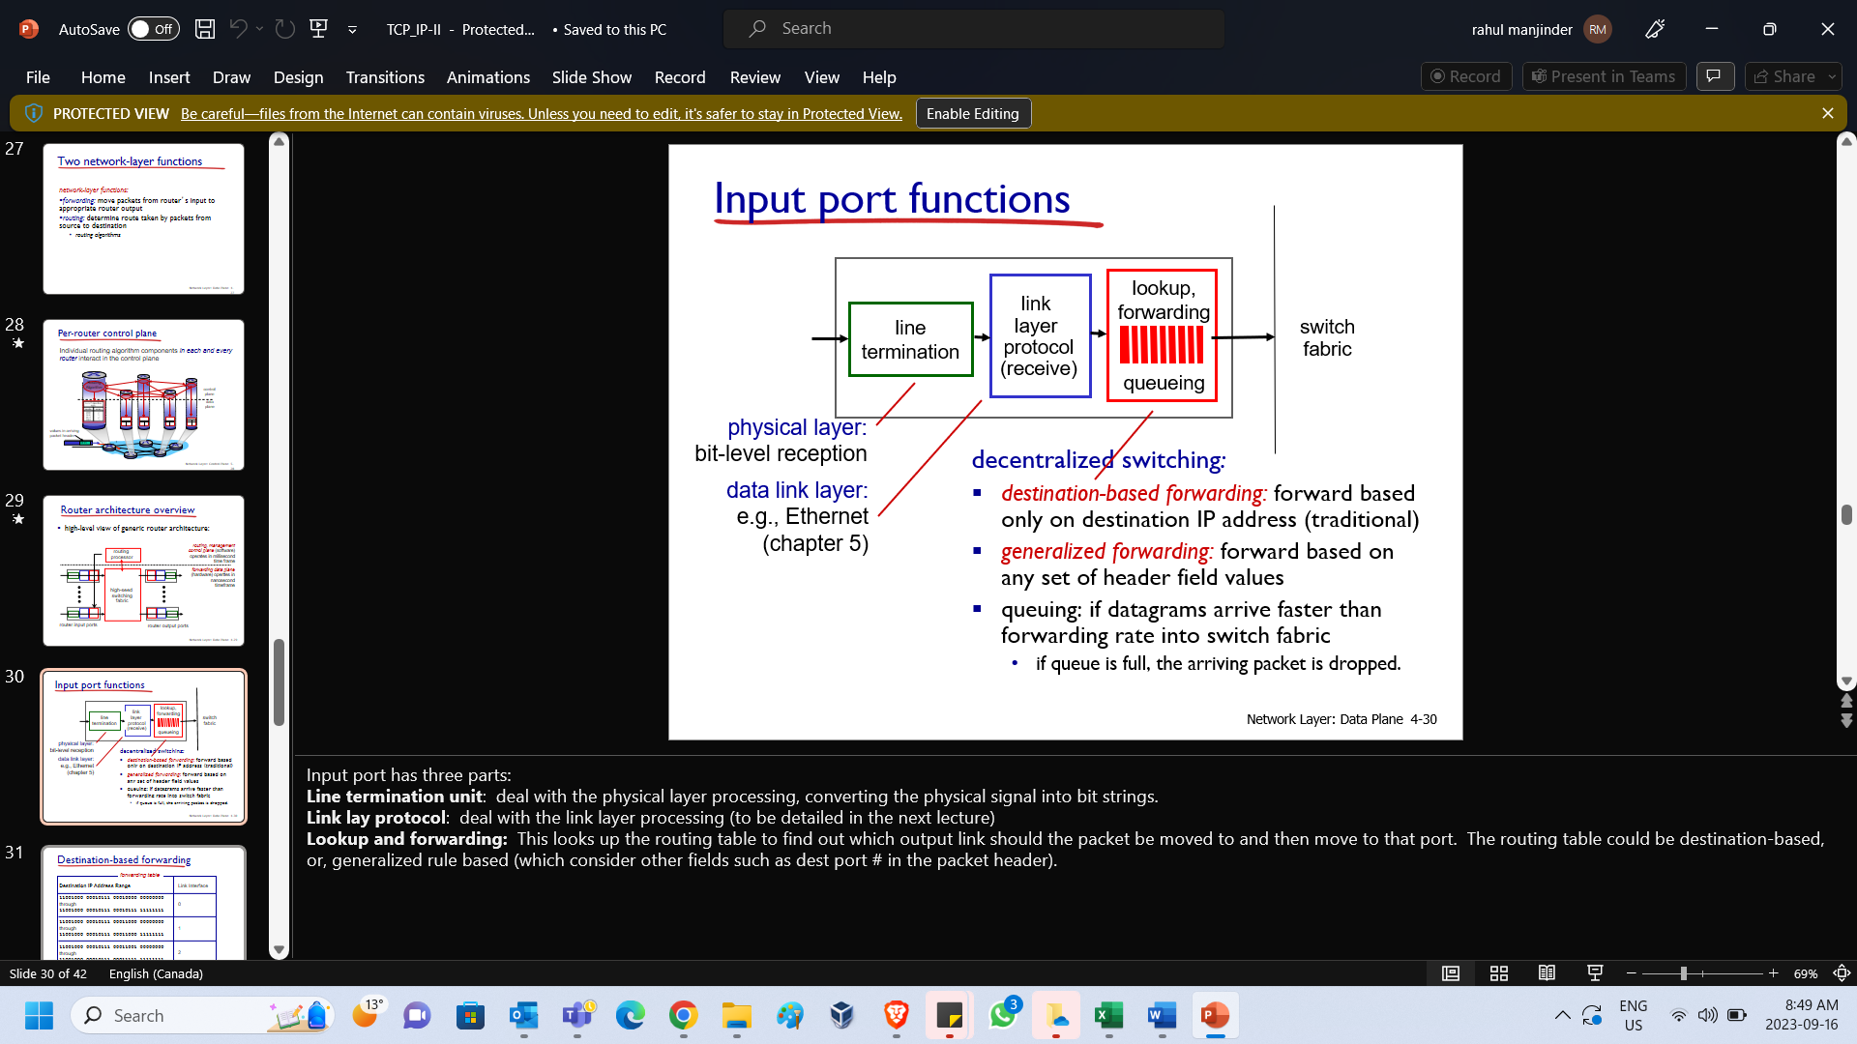

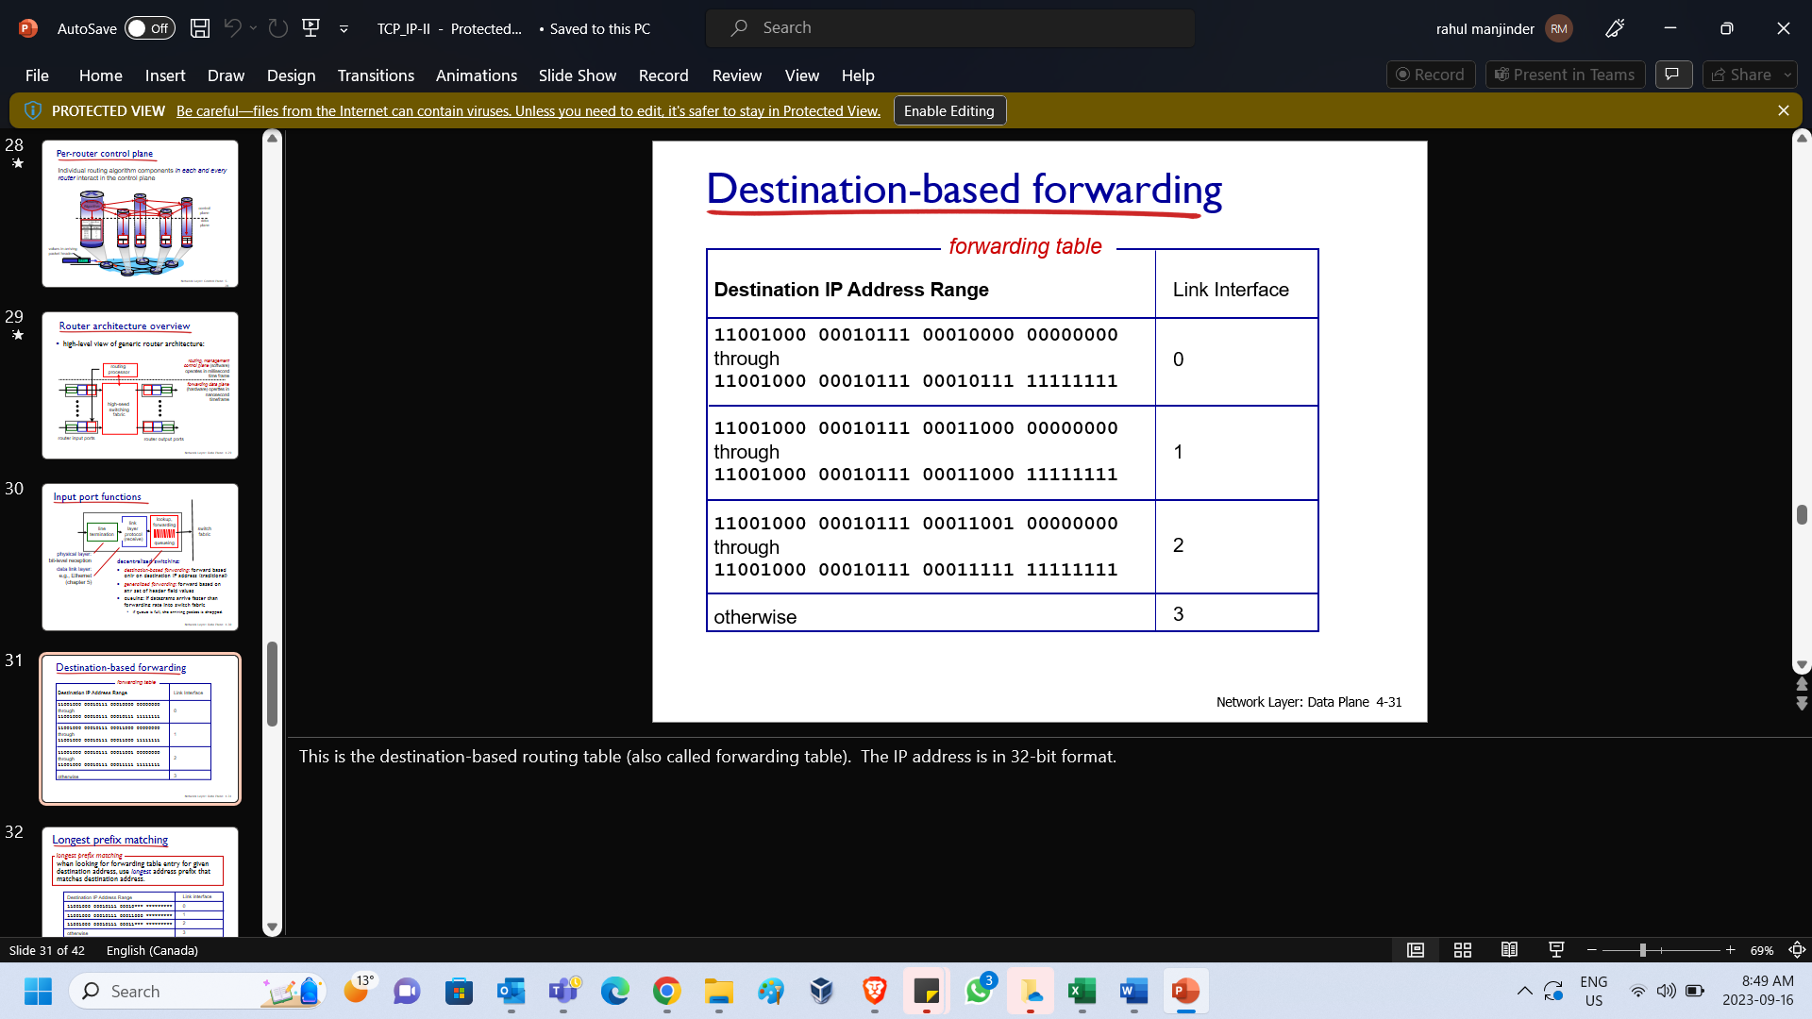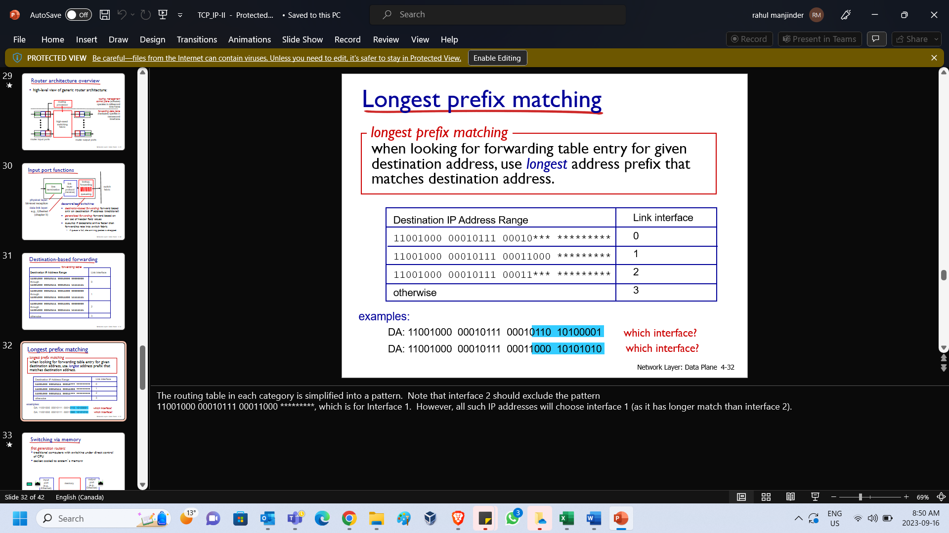

|  |  |
| --- | --- |
| This is the **destination-based routing table** (also called **forwarding table**).  The IP address is in 32-bit format. | The routing table in each category is simplified into a pattern. Note that interface 2 should exclude the pattern  11001000 00010111 00011000 *********, which is for Interface 1.  However, all such IP addresses will choose interface 1 (as it has longer match than interface 2). |

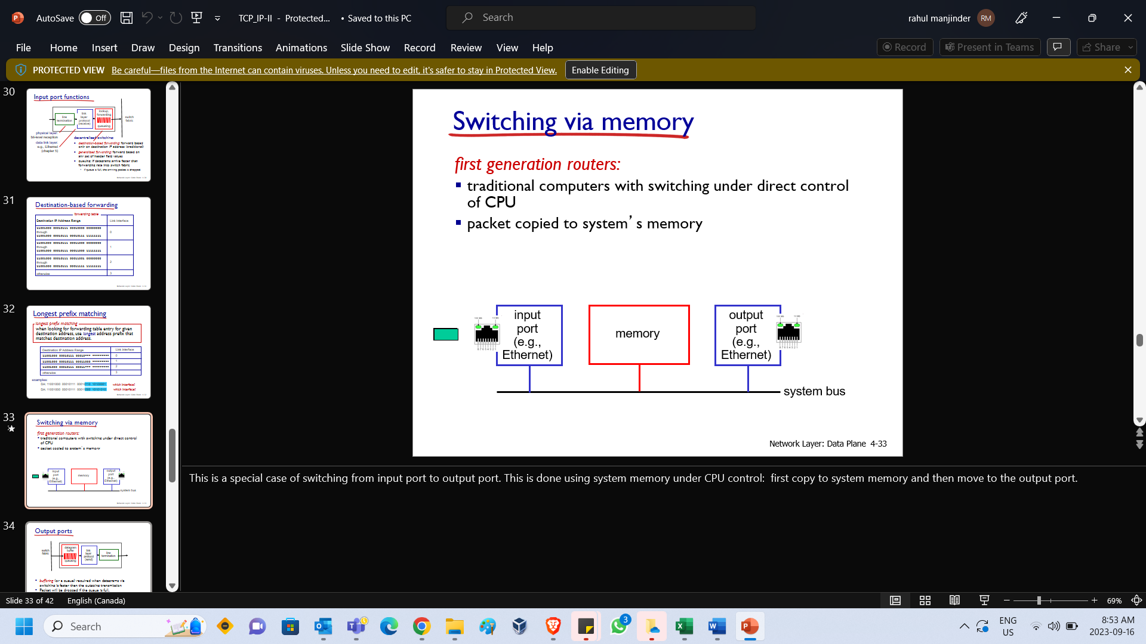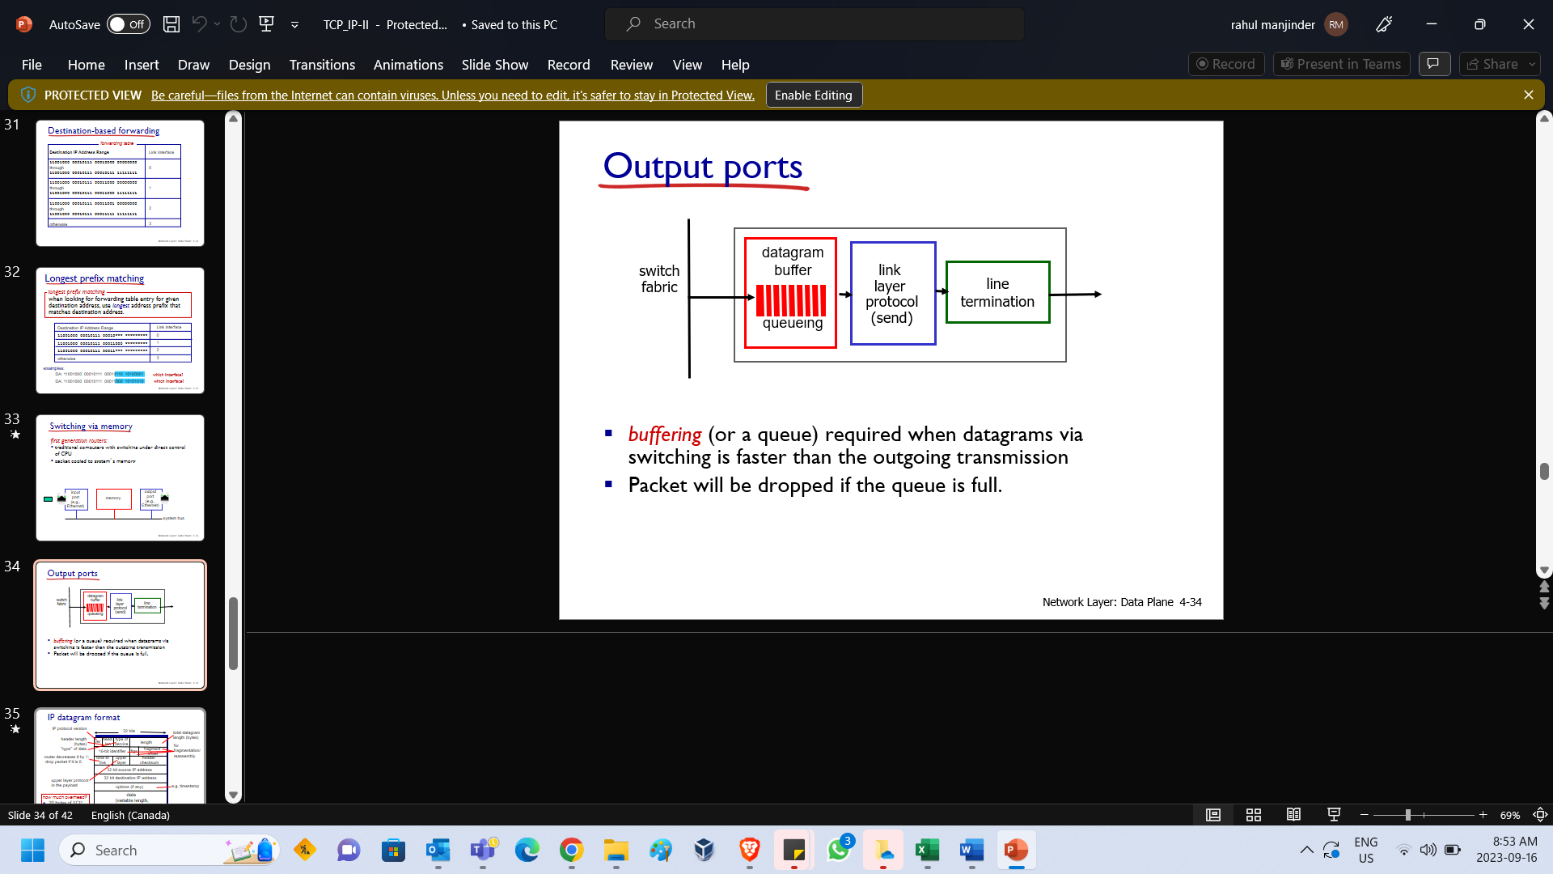

|  |  |
| --- | --- |
| This is a special case of switching from **input port to output port**.  This is done using **system memory under CPU control**: first **copy to system memory** and then **move to the output port.** | This is IPv4 header. You pay attention to **upper layer, IP addresses and TTL fields.**  Upper layer protocol is usually **TCP or UDP or ICMP**.  **ID, flags, fragment offset** is for fragmentation purpose, which is introduced in the next slide. |

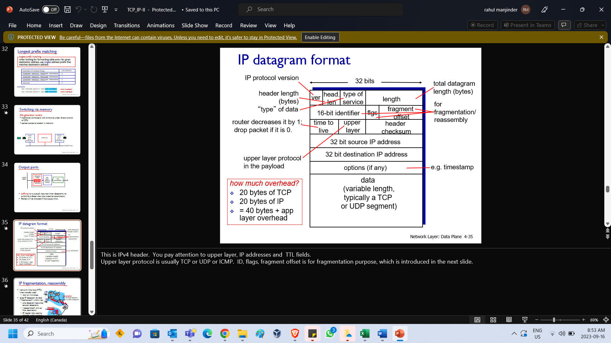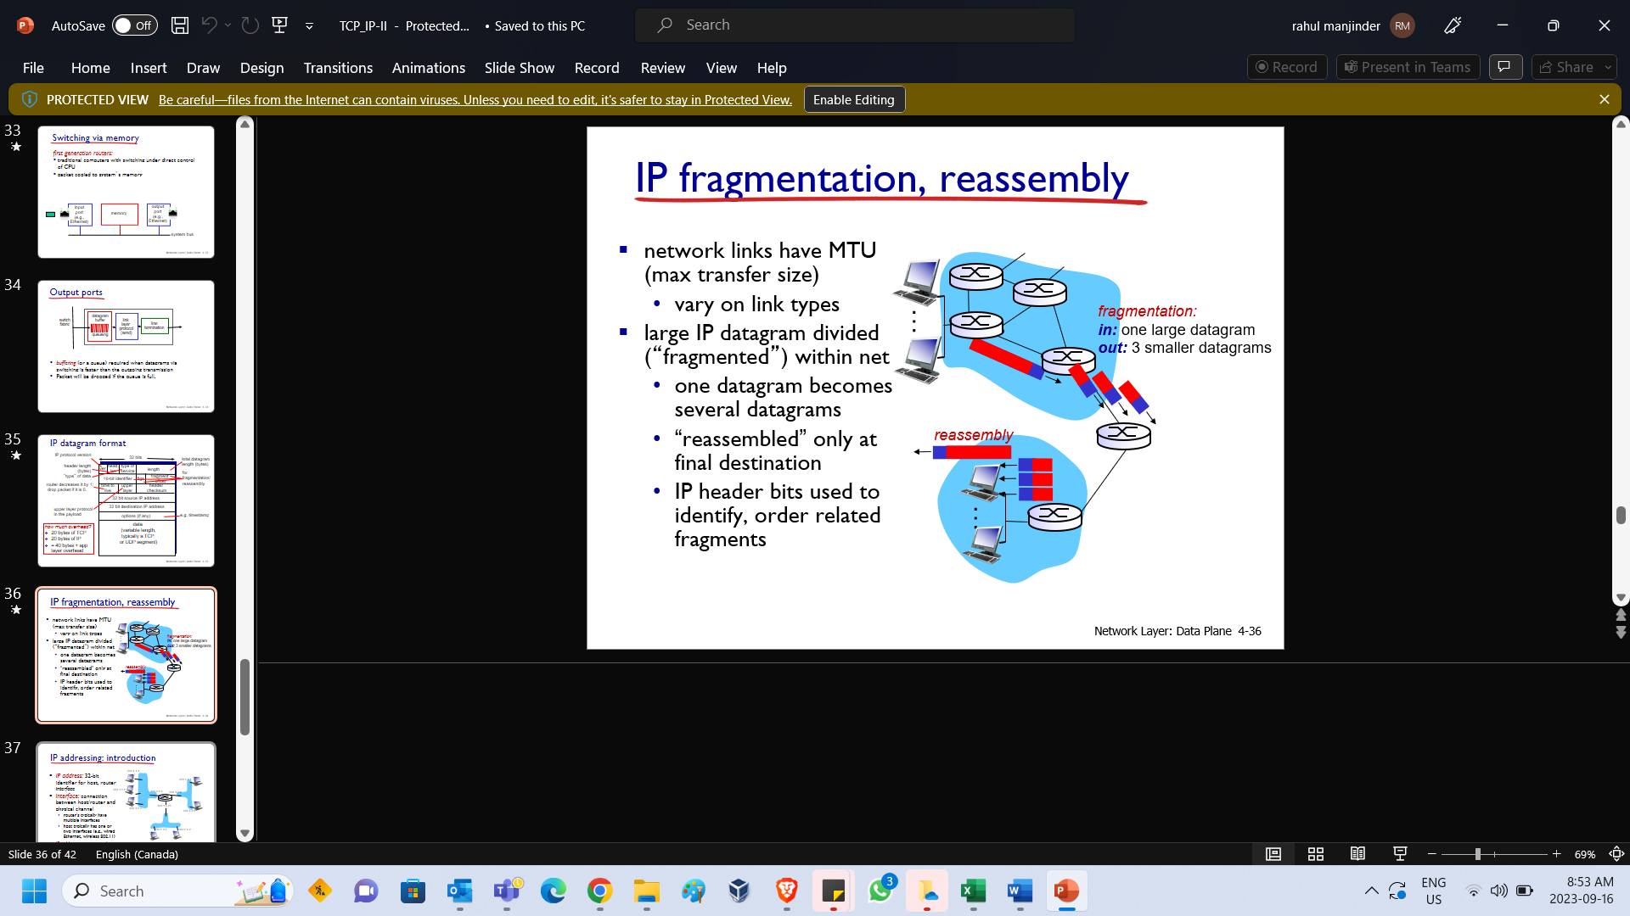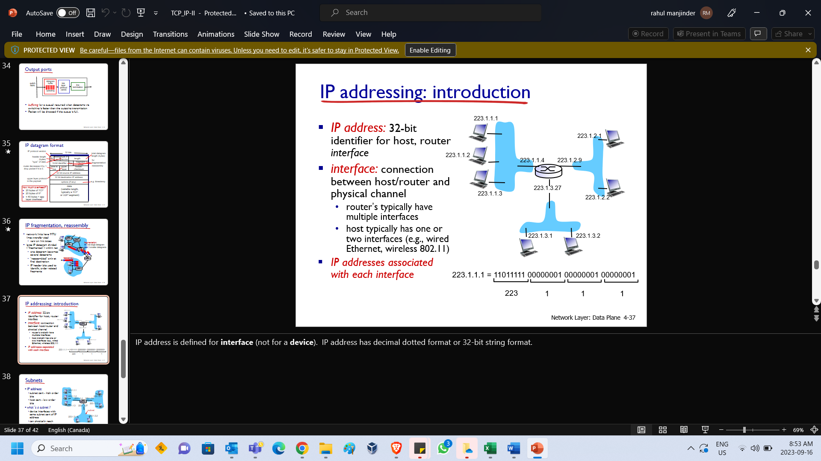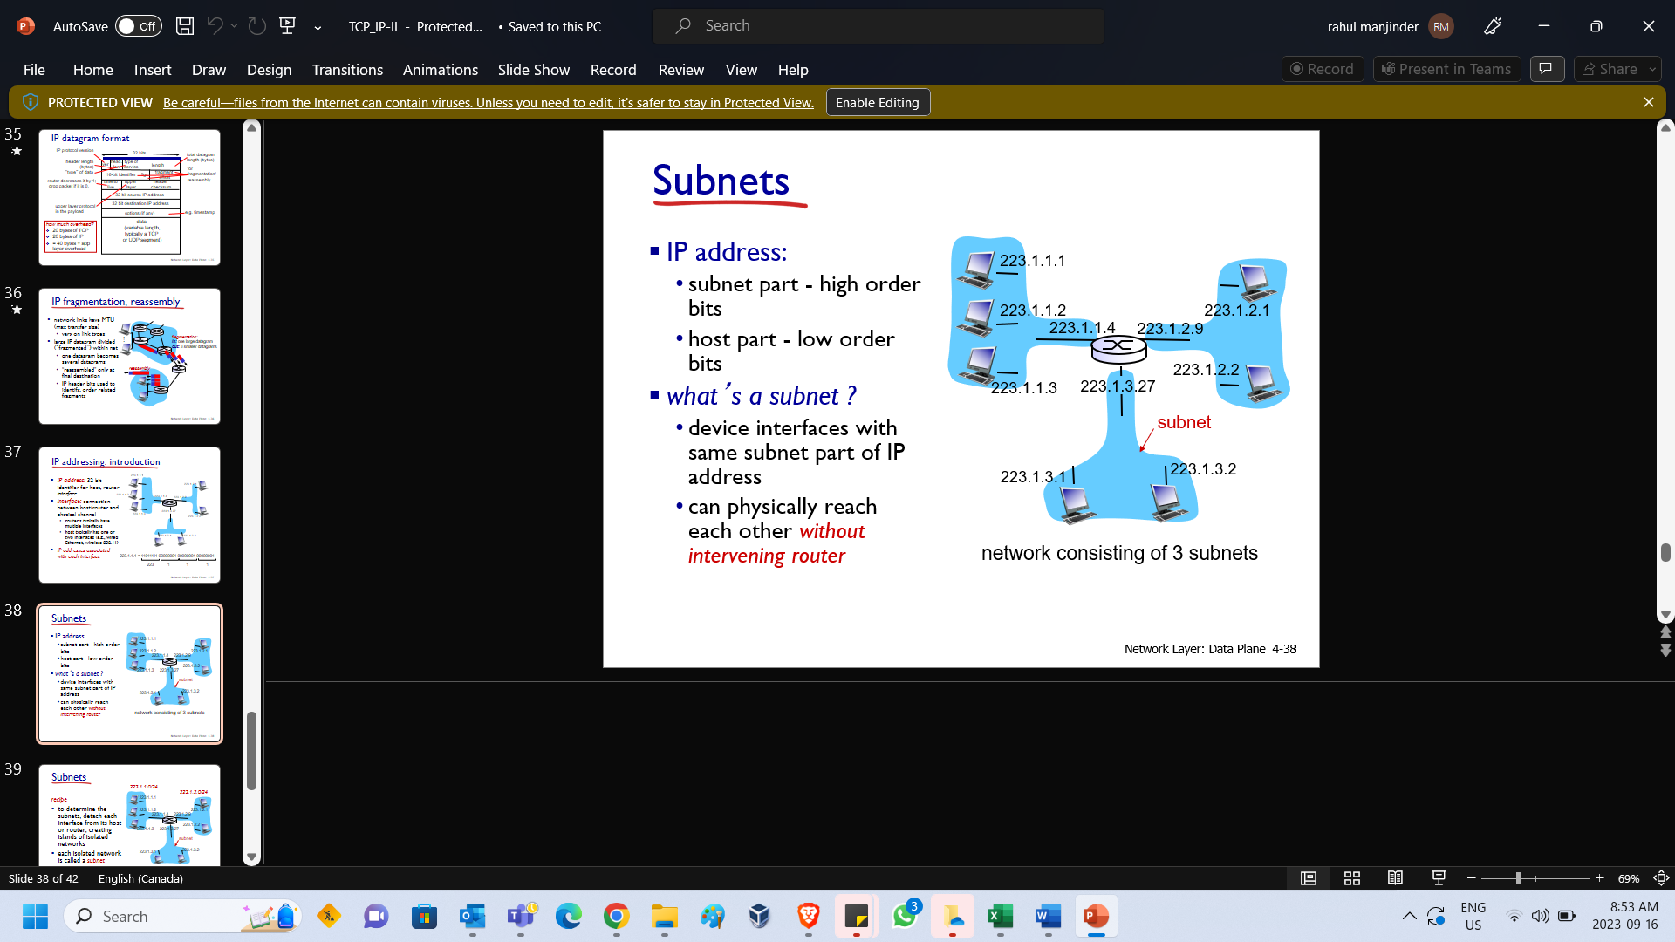

|  |  |
| --- | --- |
| IP address is defined for **interface** (not for a **device**). IP address has decimal dotted format or 32-bit string format. | 223.1.1.0/24 is the subnet that the first 24 bits are common for all devices in this network. Since 223.1.1 has 24 bits, this subnet has IP address of pattern 223.1.1.x.  223.1.1.0 is written into binary format as **11011111** **0000000**1 **00000001** 00000000 (bold parts are 24 bits). |
|  |  |

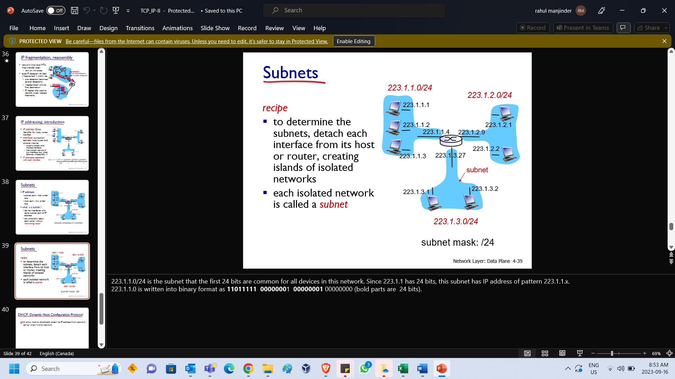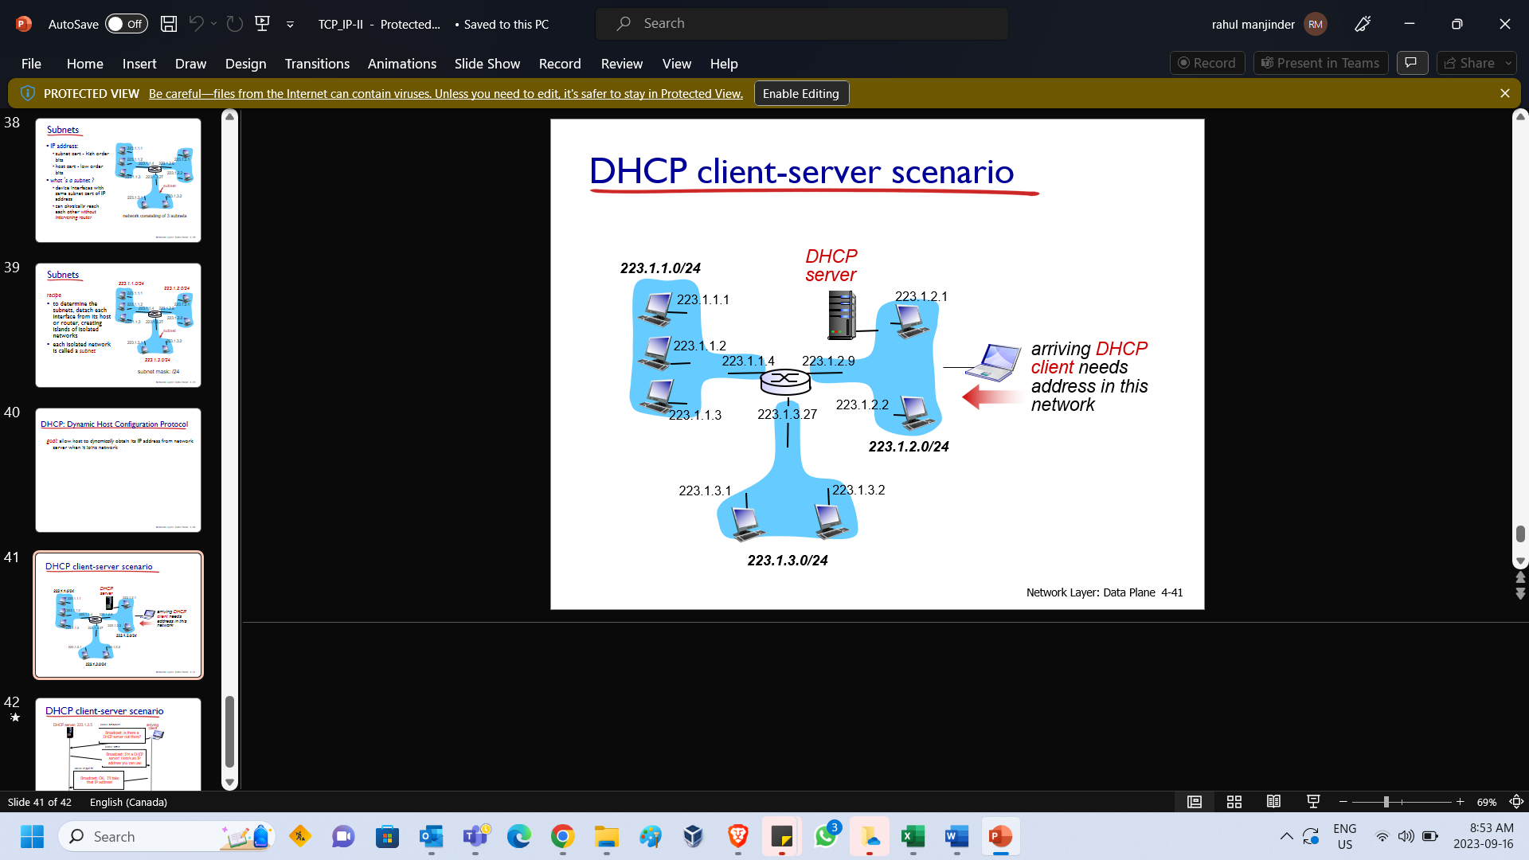

|  |  |
| --- | --- |
|  | Most importantly, DHCP protocol will provide you not just the ip address. It provides more:   * IP address for you to use * Local DNS server IP address (recall, whenever you type www.google.com, your browser will first find the IP address of google by issuing a DNS query to a local DNS server). * Local router IP address (whenever you computer needs to sends a packet out, it first needs to reach the router which then routes your packet to the internet and finally reaches the destination). * DHCP server IP address |

**Week 3 – Chapter 3 - Introduction to TCP/IP – III**

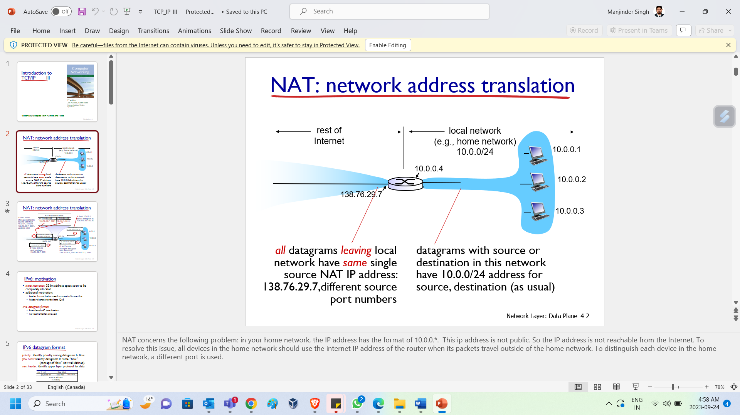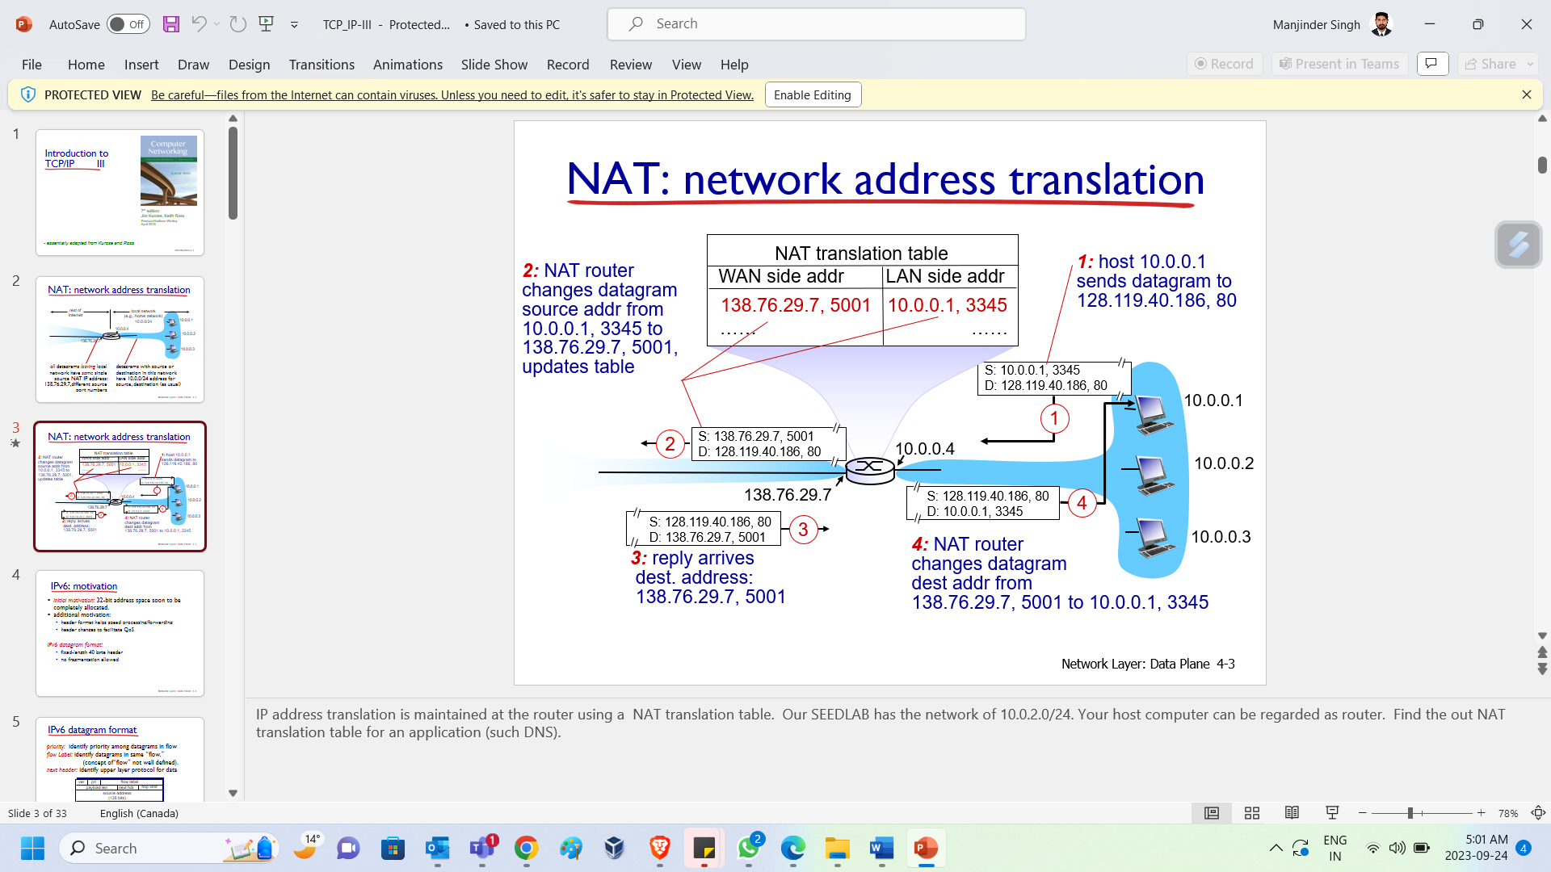

|  |  |
| --- | --- |
| **NAT concerns the following problem**: in your home network, the IP address has the format of 10.0.0.*. This ip address is not public. So the IP address is not reachable from the Internet. To resolve this issue, all devices in the home network should use the internet IP address of the router when its packets travel outside of the home network. To distinguish each device in the home network, a different port is used. | IP address translation is maintained at the router using a NAT translation table. Our SEEDLAB has the network of 10.0.2.0/24. Your host computer can be regarded as router. Find the out NAT translation table for an application (such DNS). |

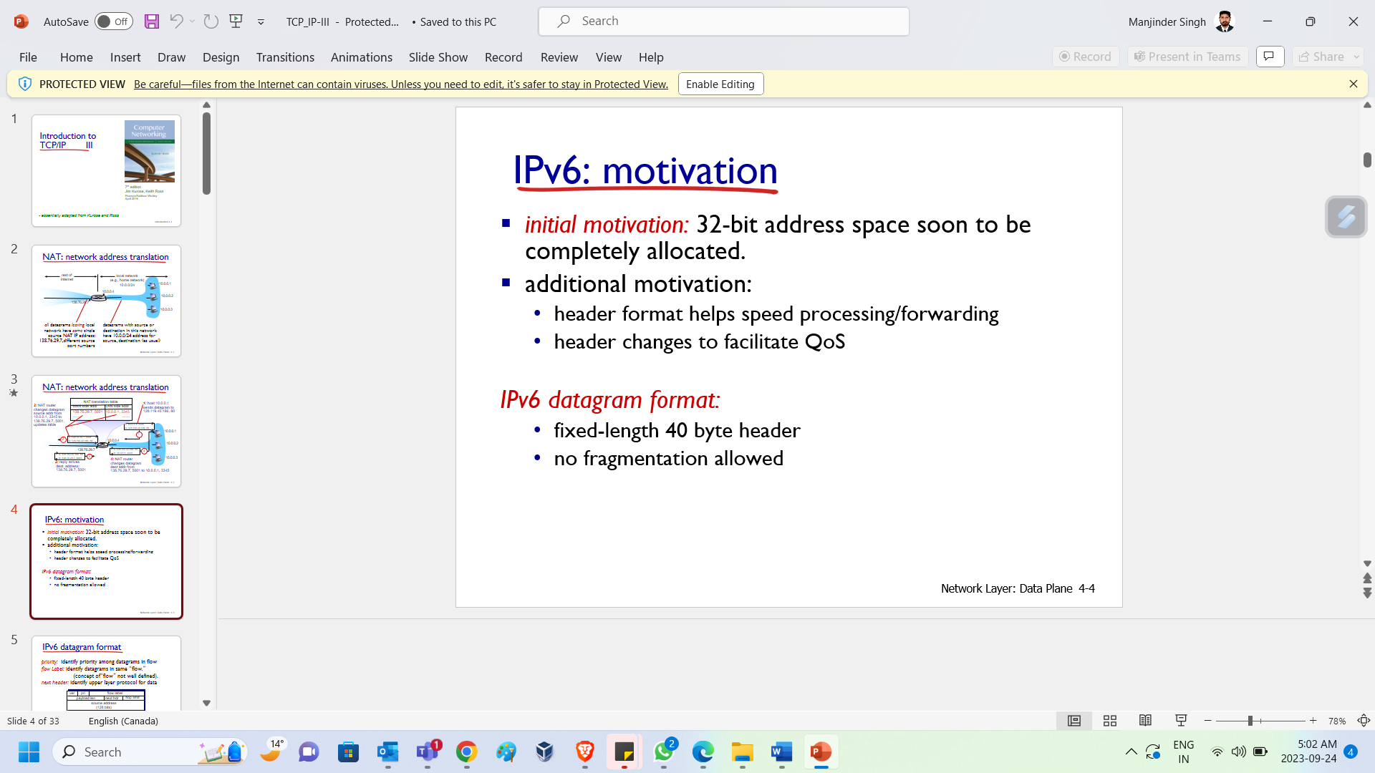 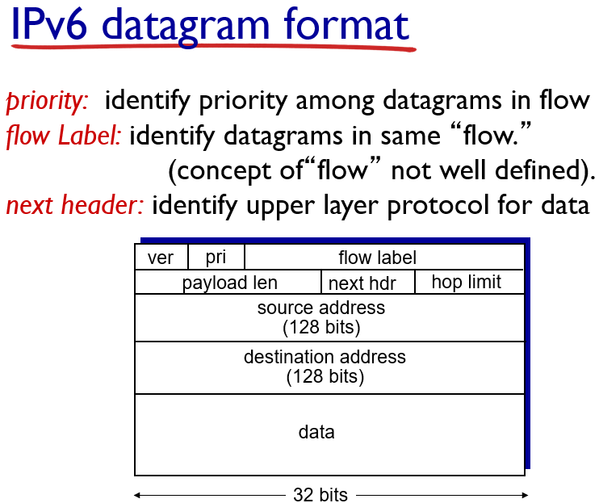

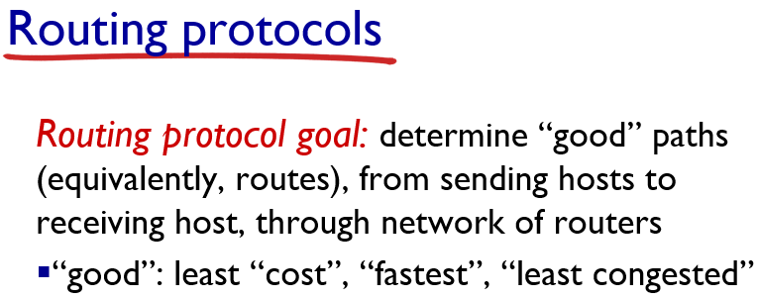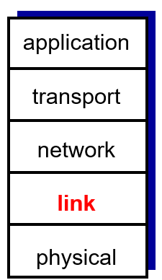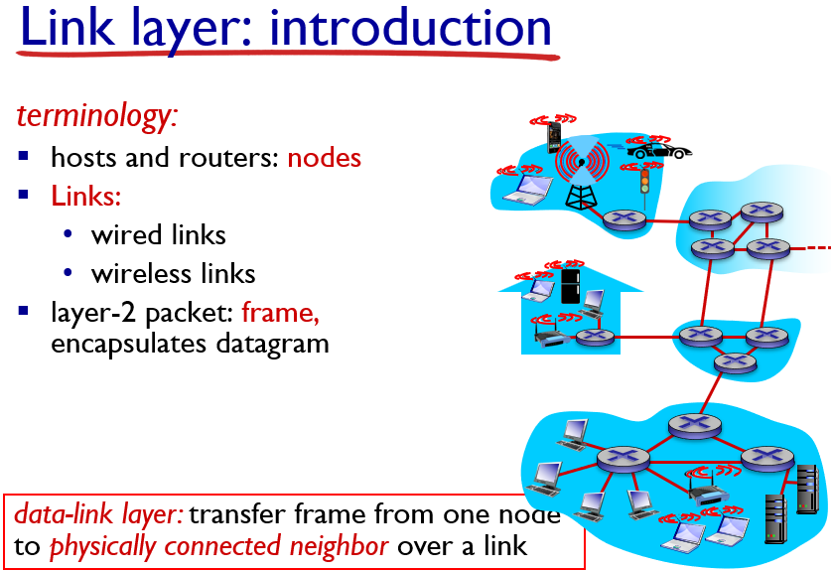

|  |  |
| --- | --- |
| **8** | Link layer is concerned with the communication between the neighboring link (either wireless or wired link). |
| **11** | **Basic task for link layer communication:** **i.** sender adds error-checking bits et al and  **ii.** sends to the receiver (of the neighboring device).  The receiver verifies the link layer header and sends the enclosed packet (datagram) to the upper layer (mostly network layer). |
| **12** | If the media from the sender to receiver is **point-to-point connection**, then it is simple via **point-to-point communication**. But there are some medias that are shared. |
| **13** | In this case, if two users send the packet at the same time, they will interference each other. So **multiple access protocol** is used to determine the order of the channel access. |
| **14** | This page shows the difference between IP address and MAC address.  **IP address is not portable.** |

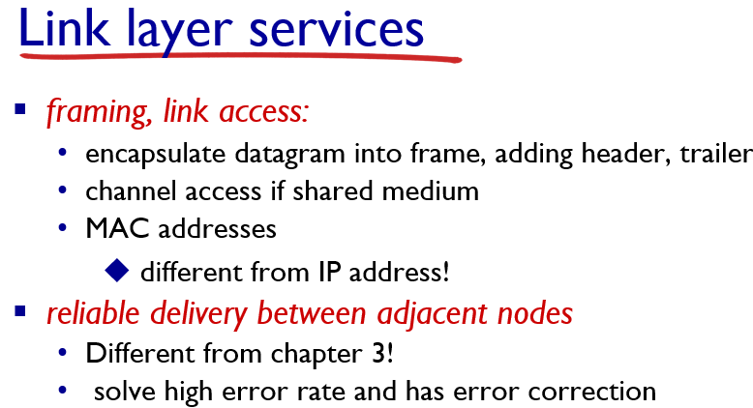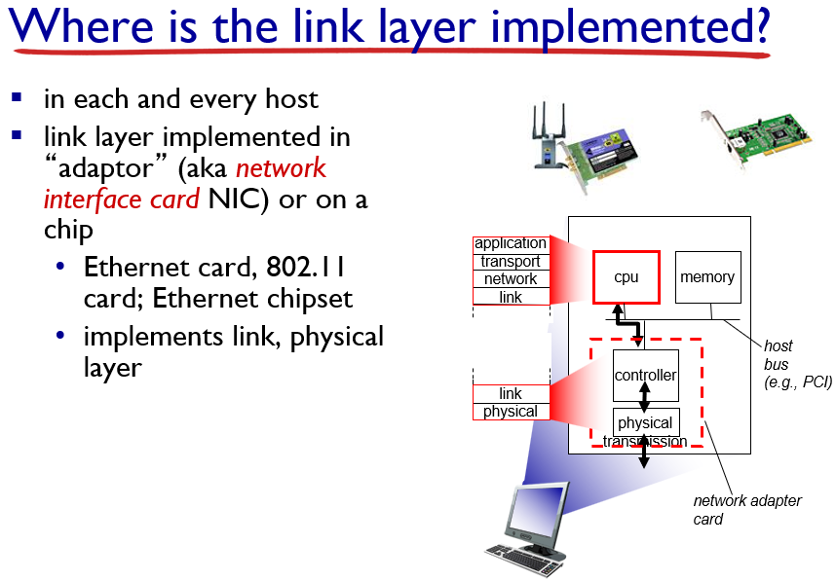

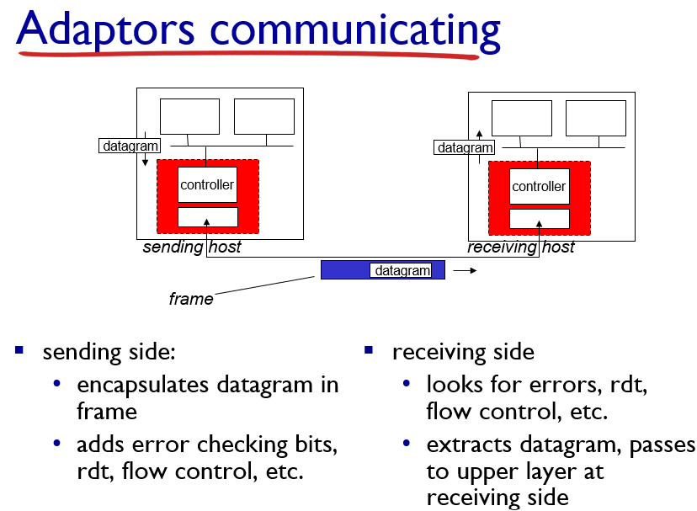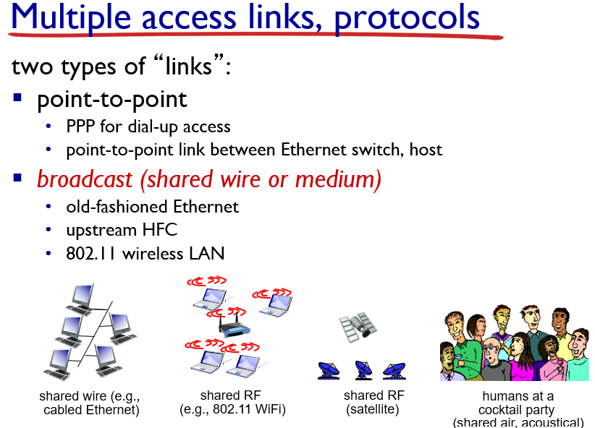

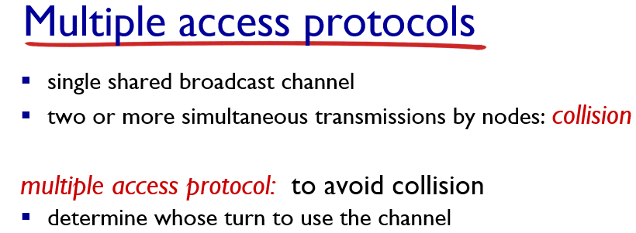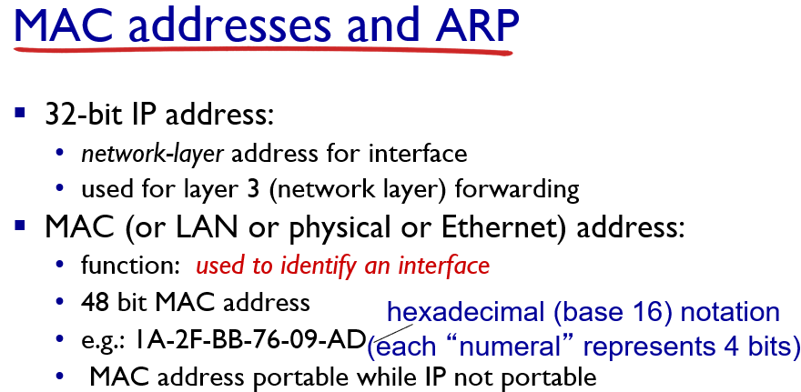

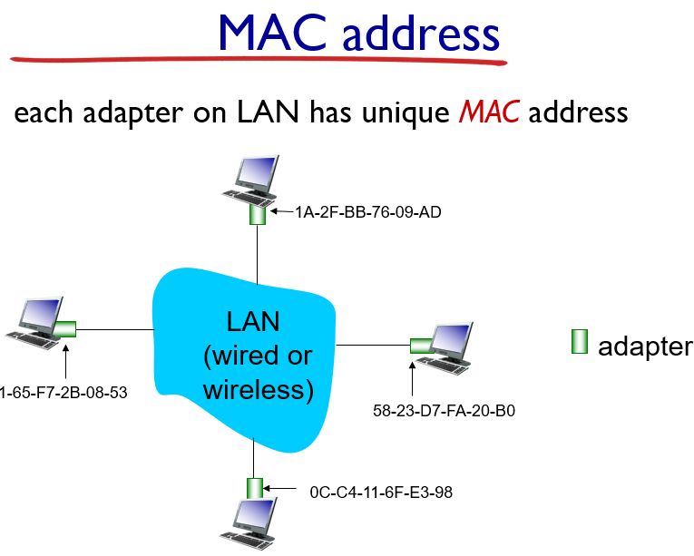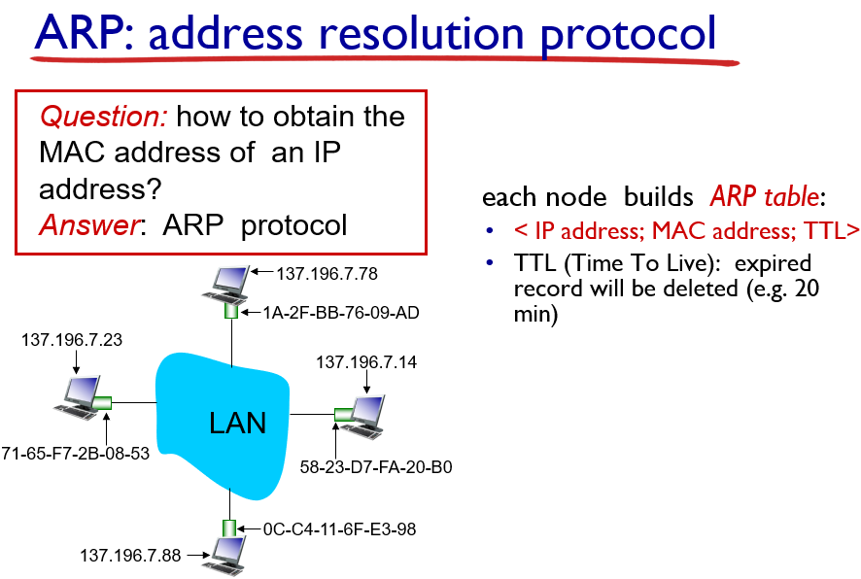

|  |  |
| --- | --- |
| **15** | MAC address is attached to an interface. |
| **16** | Since link layer communication uses frame (i.e., link layer packet) which contains the MAC address. If A wants to send a frame to B, A has to first obtain the MAC address of B. This uses ARP protocol to obtain this address. It is important that this protocol is running only **within** the LAN (such as your home network), because different subnets are **separated** by router and so you **never** need to send a frame to a device outside your LAN (**recall** that link layer communication only sends a frame to its neighboring device). |

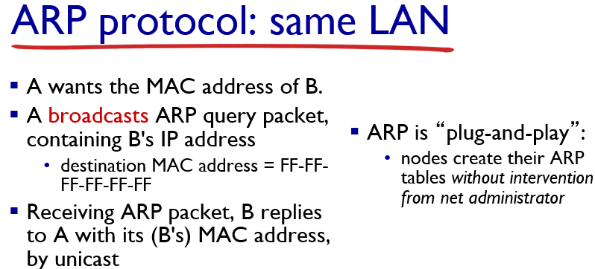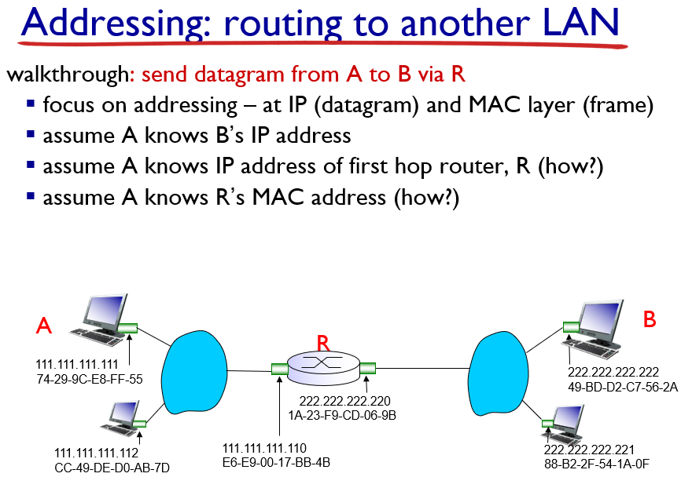

|  |  |
| --- | --- |
| **17** | This is how the ARP protocol is working. The basic idea is to broadcast the question (identified by IP address) and the IP address owner will reply. **The important point is that there is no configuration is required for this protocol.** |
| **18** | This page shows you how hosts from different subnets communicate. That is, how the linker MAC addresses change along the path. You only need to stick to one point: **neighboring communication uses the neighboring devices’ MAC addresses.** |

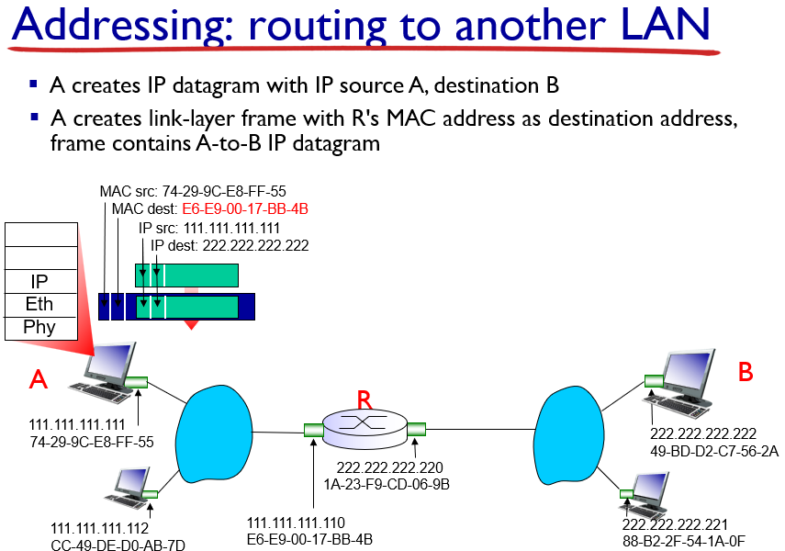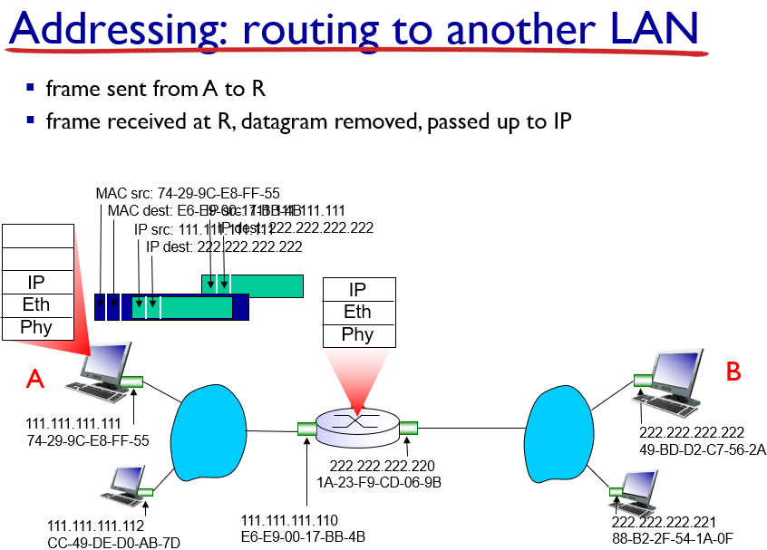

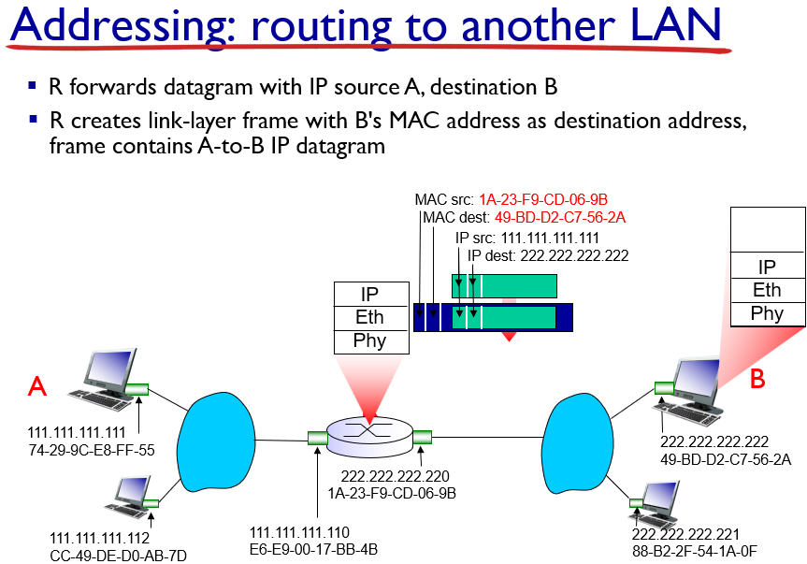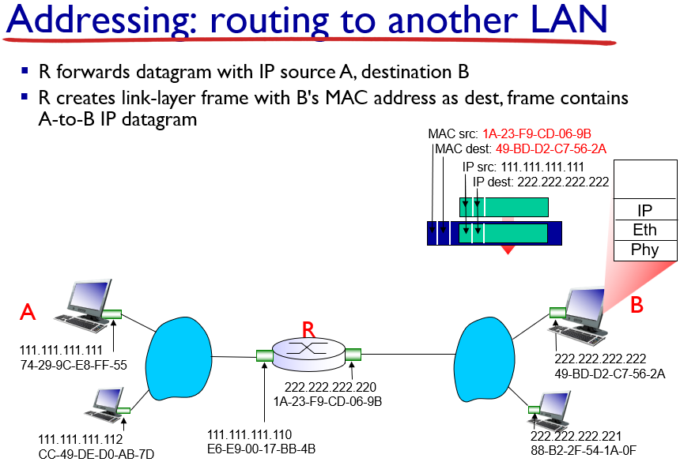

|  |  |
| --- | --- |
| **24** | **Ethernet protocol** is a very basic and essential **link layer communication protocol**. This paper is concerned with the shared media.  This is the link layer header (for the Ethernet communication link). The wireless link will have a different header, which will not be considered in this overview. |
| **26** | Previously, we said link layer communication only sends a packet between neighboring device. This is not accurate: a link layer switch can help two indirectly connected devices to have link layer communication, by forwarding their packets back and forth without changing anything. So in view of the communication devices, they are directly connected. |
| **27** | A-A’ and B-B’ communication have no shared source/destion. Switch can deliver the packet simultaneously. |

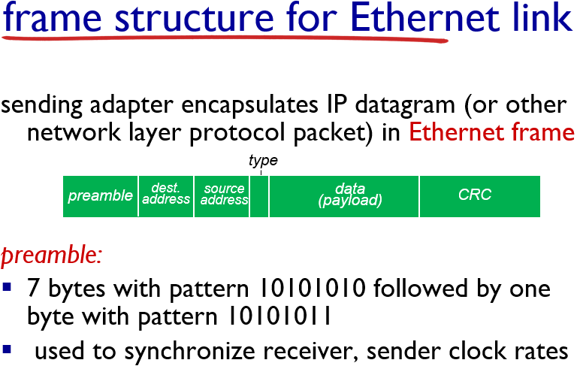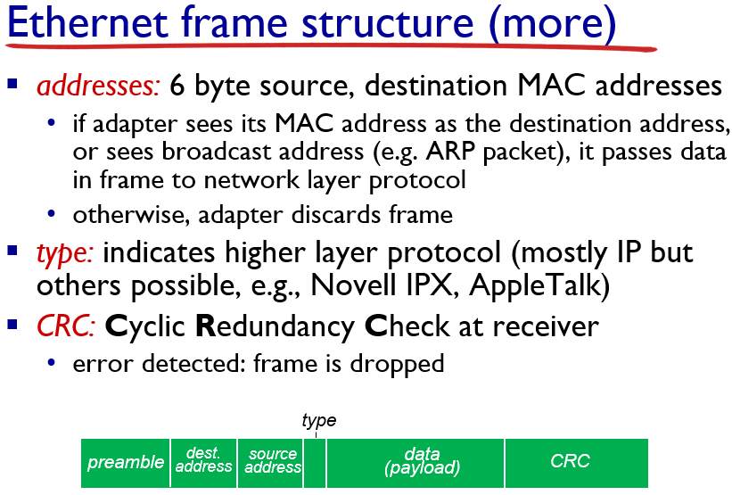

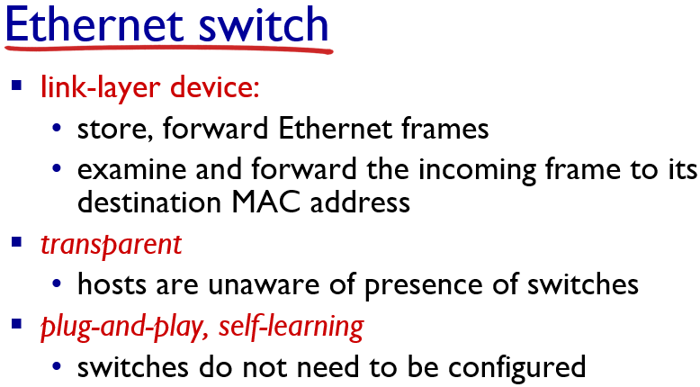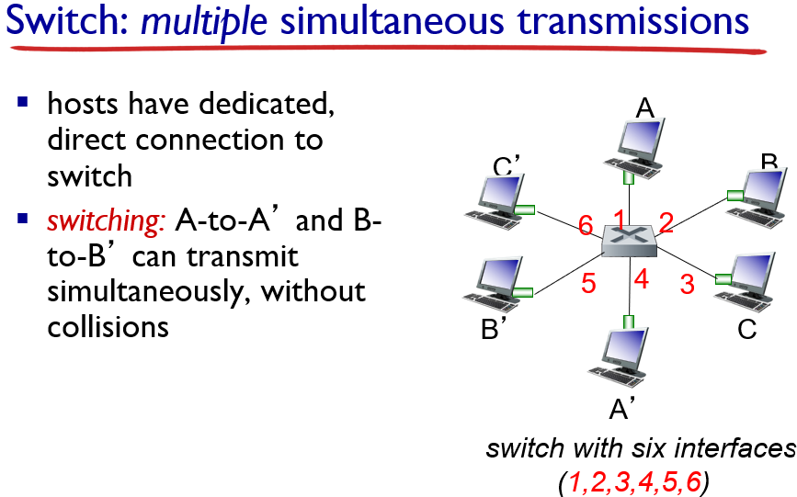

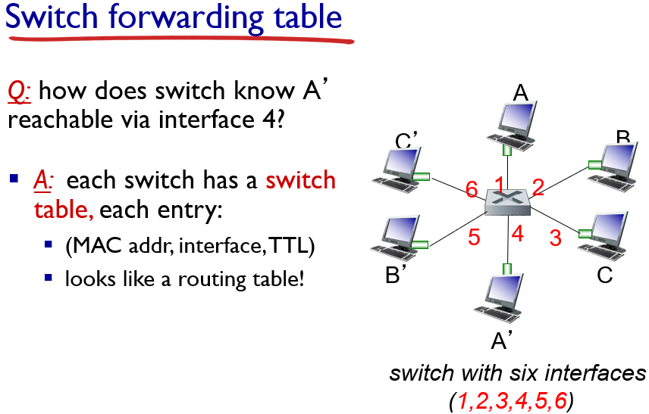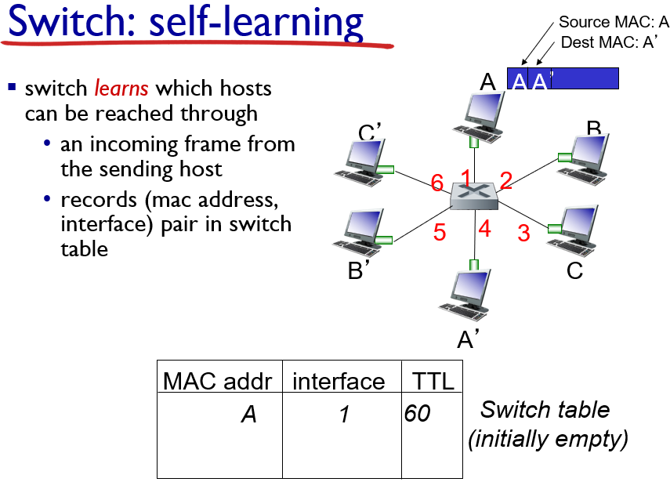

|  |  |
| --- | --- |
| **28** | It is better to compare this switch table with arp table and routing table. They are built differently.   * **ARP table** is built by **requesting the ip holder to provide the MAC address**. * **Routing table** is built by **running routing algorithm with several routers.** * **Switch table** is built by **receiving the incoming packet and record the (MAC address, link interface) pair**; see the next slides for details. |
| **30** | You can first skip this and look at the example on the next slide and then come back to this general algorithm. |

